**VIVEKANAND EDUCATION SOCIETY’S INSTITUTE OF TECHNOLOGY**

**(An Autonomous Institute Affiliated to University of Mumbai)**

**Department of Computer Engineering**



Project Report on

TRAVELSAGE: AN AI BASED SYSTEM FOR TOURISTS

Submitted in partial fulfillment of the requirements of the degree

**BACHELOR OF ENGINEERING** IN **COMPUTER ENGINEERING**

By

Vaishnavi Chavan (10)

Shreya Nalawade(36)

Gayatri Vaidya (63)

**Project Mentor**

Dr.(Mrs.) Gresha Bhatia

**University of Mumbai**

**(AY 2023-24)**

**VIVEKANAND EDUCATION SOCIETY’S INSTITUTE OF TECHNOLOGY**

**(An Autonomous Institute Affiliated to University of Mumbai)**

**Department of Computer Engineering**



# CERTIFICATE

This is to certify that the Mini Project entitled **“TravelSage: An AI based system for Tourists ”** is a bonafide work of **Vaishnavi Chavan (10), Shreya Nalawade(36), Gayatri Vaidya(63)** submitted to the University of Mumbai in partial fulfillment of the requirement for the award of the degree of **“Bachelor of Engineering”** in **“Computer Engineering” .**

## (Prof.Dr.(Mrs.)Gresha Bhatia)

Mentor

## (Prof.Dr.(Mrs.)Nupur Giri) (Prof.Dr.(Mrs.) J.M. Nair)

Head of Department Principal

# Mini Project Approval

This Mini Project entitled “**TravelSage: An AI based system for Tourists”** by **Vaishnavi Chavan (10), Shreya Nalawade(36), Gayatri Vaidya(63)** is approved for the degree of **Bachelor of Engineering** in **Computer Engineering.**

**Examiners**

**1………………………………………**

(Internal Examiner Name & Sign)

## 2…………………………………………

## (External Examiner name & Sign)

Date: Place:

**Declaration**

We declare that this written submission represents our ideas in our own words and where others' ideas or words have been included, we have adequately cited and referenced the original sources. We also declare that we have adhered to all principles of academic honesty and integrity and have not misrepresented or fabricated or falsified any idea/data/fact/source in our submission. We understand that any violation of the above will be cause for disciplinary action by the Institute and can also evoke penal action from the sources which have thus not been properly cited or from whom proper permission has not been taken when needed.

| -----------------------------------------  (Signature)  -----------------------------------------  (Name of student and Roll No.) | -----------------------------------------  (Signature)  -----------------------------------------  (Name of student and Roll No.) |
| --- | --- |
| -----------------------------------------  (Signature)  -----------------------------------------  (Name of student and Roll No.) |  |

Date:

**ACKNOWLEDGEMENT**

We are thankful to our college Vivekanand Education Society’s Institute of Technology for considering our project and extending help at all stages needed during our work of collecting information regarding the project.

It gives us immense pleasure to express our deep and sincere gratitude to Deputy Head of the Computer Department **Dr.(Mrs.)Gresha Bhatia** (Project Guide) for her kind help and valuable advice during the development of project synopsis and for her guidance and suggestions.

We are deeply indebted to Head of the Computer Department **Dr.(Mrs.) Nupur Giri** and our Principal **Dr. (Mrs.) J.M. Nair ,** for giving us this valuable opportunity to do this project.

We express our hearty thanks to them for their assistance without which it would have been difficult in finishing this project synopsis and project review successfully.

We convey our deep sense of gratitude to all teaching and non-teaching staff for their constant encouragement, support and selfless help throughout the project work. It is great pleasure to acknowledge the help and suggestion, which we received from the Department of Computer Engineering.

We wish to express our profound thanks to all those who helped us in gathering information about the project. Our families too have provided moral support and encouragement several times.

**Index**

**PageNo**

**Abstract**  9

**Chapter 1: Introduction 10**

1.1 Introduction 10

1.2 Motivation 10

1.3 Problem Definition 11

1.4 Existing Systems 11

1.5 Lacuna of the existing systems 12

1.6 Relevance of the Project 13

**Chapter 2: Literature Survey** 14

A. Brief Overview of Literature Survey 14

B. Related Works 14

2.1 Research Papers Referred 14

a. Abstract of the research paper

b. Inference drawn

2.2 Limitations in the existing system or research gap 17

**Chapter 3: Requirement Gathering for the Proposed System 19**

3.1 Introduction to requirement gathering 19

3.2 Functional Requirements 19

3.3 Non-Functional Requirements 19

3.4.Hardware, Software , Technology and tools utilized 20

3.5 Constraints 20

**Chapter** **4: Proposed Design 22**

4.1 Block diagram of the system 22

4.2 Sequence Diagram 22

4.4 Project Scheduling & Tracking using Timeline / Gantt Chart 23

**Chapter 5: Implementation of the Proposed System 24**

5.1. Methodology employed for development 24

5.2 Algorithms and flowcharts for the respective modules developed 25

5.3 Datasets source and utilization 32

**Chapter 6: Testing of the Proposed System 33**

6.1. Introduction to testing 33

6.2. Types of tests Considered 33

6.3 Various test case scenarios considered 33

6.4. Inference drawn from the test cases 34

**Chapter 7: Results and Discussion 35**

7.1. Screenshots of User Interface (UI) for the respective module 35

7.2. Performance Evaluation measures 41

7.3. Input Parameters / Features considered 41

7.4 Comparison of results with existing systems 42

7.5 Inference drawn 42

**Chapter 8: Conclusion**

8.1 Limitations 43

8.2 Conclusion 43

8.3 Future Scope 44

**References**

**Appendix**

**1. Research Paper Details**

1. Paper published
2. Certificate of publication / Project Competition
3. Plagiarism report
4. Project review sheet

**List of Figures:**

| **Figure Title** | **Page No** |
| --- | --- |
| Block Diagram | 22 |
| Sequence Diagram | 22 |
| Gantt Chart | 23 |
| Prototype Model | 25 |
| Flowchart for user authentication | 26 |
| Flowchart for itinerary generation | 28 |
| Flowchart for Hotel and flight booking | 29 |
| Flowchart for virtual tours | 30 |
| Flowchart for AI place detection | 31 |
| Explanation of image processing | 32 |
| Selenium Testing | 34 |
| Login page | 35 |
| Home page | 35 |
| Itinerary generator- part1 | 36 |
| Itinerary generator- part2 | 36 |
| Map | 37 |
| Hotel Booking | 37 |
| URL generated for hotels | 38 |
| Flight Booking | 38 |
| Booking.com link for flight booking | 39 |
| Ai place detector | 39 |
| Virtual tours | 40 |

**Abstract**

The tourism industry is currently undergoing a profound transformation, largely driven by the integration of cutting-edge Artificial Intelligence (AI) technologies. One such pioneering initiative is TravelSage, a platform that introduces an innovative approach to enriching the tourism experience through the implementation of an Intelligent Tourism System. This groundbreaking system seamlessly merges AI-powered chatbot technologies to deliver personalized and frictionless services to travelers.At the heart of TravelSage lies its AI-based chatbot, meticulously crafted using advanced tools like Langchain and the OpenAI Assistant system. This chatbot serves as a proficient guide, adept at crafting tailored itineraries based on users' preferences and interests. Whether one seeks adventurous escapades, cultural immersions, or leisurely pursuits, the chatbot adeptly curates bespoke travel plans, ensuring an unforgettable journey for every individual.Moreover, TravelSage offers an array of supplementary features to enrich the travel experience further. One such feature is virtual tours, providing users with comprehensive insights and captivating glimpses into their desired destinations. These immersive experiences allow travelers to familiarize themselves with the attractions and ambiance of their chosen locales, fostering anticipation and excitement for their upcoming adventures.Additionally, TravelSage facilitates hassle-free accommodation and travel arrangements with its integrated hotel accommodation and flight booking functionalities. With a user-friendly interface and intuitive navigation, travelers can effortlessly browse, compare, and reserve accommodations and flights, streamlining the entire travel planning process.

1. **Introduction**

**1.1 Introduction**

In the era of digital innovation, the tourism industry is undergoing a paradigm shift, reshaping the way travelers plan, experience, and remember their journeys. Advancements in Artificial Intelligence (AI) have paved the way for intelligent systems that enhance user experiences, and among these, AI-based recommendations and chatbots are revolutionizing the tourism landscape. TravelSage is a platform that delves into the fusion of these cutting-edge technologies, introducing the Tourism System AI-Based Recommendation and Chatbot Project.Traditional tourism planning often faces challenges in catering to individual preferences and dynamic travel landscapes. AI-based recommendation systems have emerged as powerful tools for personalizing travel experiences. By analyzing vast datasets encompassing traveler preferences, historical choices, and real-time trends, these systems provide tailored suggestions, enhancing the relevance and enjoyment of travel itineraries.

**1.2 Motivation**

The motivation behind the development of the Tourism System AI-Based Recommendation and Chatbot Project stems from the profound impact it can have on both travelers and the tourism industry as a whole. Several compelling factors drive the need for this innovative venture:

1. Personalized Travel Experiences: Traditional travel recommendations often lack personalization, leading to generic itineraries that might not align with individual preferences. AI-based recommendation systems can analyze vast datasets to create highly personalized travel suggestions, ensuring that every traveler receives tailored recommendations tailored to their tastes and interests.
2. Efficiency and Time-Saving: Travel planning can be time-consuming and overwhelming. AI-driven systems can process extensive information swiftly, providing users with efficient and relevant recommendations. This time-saving aspect encourages more people to explore travel options, fostering a greater interest in tourism.
3. Enhanced User Engagement: Chatbots equipped with AI and NLP capabilities offer interactive and responsive interfaces. Travelers can engage in natural conversations to get real-time information, creating a more engaging and user-friendly experience. This increased interaction enhances user satisfaction and encourages them to use the system for their travel needs.
4. Local Business Empowerment: Local businesses in tourism-centric areas often struggle to reach a broader audience. By integrating with an AI-based tourism system, these businesses can showcase their offerings to a wider range of travelers.This increased visibility can boost sales and help local economies thrive.

**1.3 Problem Definition**

In an era of rapid technological advancement, the travel industry has witnessed significant transformations. The integration of Artificial Intelligence (AI) into various aspects of travel planning and exploration has led to the emergence of innovative solutions aimed at enhancing the tourist experience. TravelSage represents one such endeavor, offering a comprehensive AI-based system tailored to the needs of modern-day travelers.

The core objective of TravelSage is to revolutionize the way tourists plan and experience their trips by leveraging AI technologies. The project aims to address several challenges faced by travelers, including:

1. Efficient Itinerary Planning: Designing a personalized itinerary can be daunting for many travelers, especially when exploring unfamiliar destinations. TravelSage aims to simplify this process by utilizing AI algorithms to generate customized itineraries based on user preferences and inputs.
2. Location Visualization: Understanding the spatial layout of destinations is crucial for effective trip planning. TravelSage addresses this challenge by integrating mapping functionalities, allowing users to visualize the locations mentioned in their itinerary on a map interface.
3. Accommodation and Transportation: Finding suitable accommodation and convenient transportation options can be time-consuming tasks for travelers. TravelSage streamlines this process by offering features to search for hotels and flights, enabling users to make informed decisions efficiently.
4. Place Recognition: Identifying landmarks and attractions from images can be a manual and error-prone process. TravelSage employs AI-based image recognition techniques to automatically detect and label places, facilitating seamless integration of user-generated content into trip planning.
5. Virtual Tours: Traditional travel planning often relies on static information sources such as text descriptions and images. TravelSage introduces the concept of virtual tours, enabling users to explore destinations remotely through immersive multimedia experiences.

**1.4 Existing Systems**

1. Google Trips: Google Trips utilizes AI algorithms to provide personalized travel recommendations, itinerary suggestions, and activity recommendations based on user preferences and past travel history. It also offers features like real-time flight tracking and restaurant recommendations.
2. TripAdvisor: TripAdvisor employs AI to analyze user reviews and ratings to provide personalized recommendations for accommodations, restaurants, and attractions. It also utilizes AI for sentiment analysis to gauge the overall sentiment of reviews.
3. Airbnb: Airbnb uses AI algorithms to match travelers with suitable accommodations based on their preferences, search history, and previous bookings. It also offers personalized recommendations for experiences and activities in the destination city.
4. Expedia: Expedia employs AI-powered tools for dynamic pricing, personalized recommendations, and predictive analytics to offer customized travel packages and deals to users.
5. Booking.com: Booking.com utilizes AI for personalized search results, dynamic pricing, and virtual travel assistants to assist users in finding the perfect accommodation and activities for their trip.
6. Hopper: Hopper leverages AI algorithms to analyze vast amounts of flight and hotel data to predict future prices and recommend the optimal time to book for the best deals.
7. Waymo: While not directly related to tourism, autonomous vehicle companies like Waymo are poised to revolutionize transportation for tourists, offering AI-driven self-driving cars for convenient and efficient travel experiences.

**1.5 Lacuna of the existing systems**

1. Manual Itinerary Planning: Traditional travel booking systems often require users to manually research and plan their itineraries. This process can be time-consuming and overwhelming, especially for travelers unfamiliar with their destination. Lacunas arise in the lack of personalized recommendations and efficient itinerary generation tools, leading to suboptimal travel experiences.
2. Limited Visualization: Many traditional travel booking platforms provide textual descriptions and static images of destinations, hotels, and attractions. Lacunas exist in the limited visualization capabilities, as users may struggle to gain a comprehensive understanding of the spatial layout and geographical context of their travel plans. This can hinder decision-making and lead to dissatisfaction with chosen accommodations or activities.
3. Fragmented Booking Process: Lacunas in traditional booking systems stem from the fragmented nature of the booking process. Users often have to visit multiple websites or use separate platforms to book flights, accommodations, tours, and activities. This disjointed experience can result in inefficiencies, confusion, and missed opportunities for cost savings or bundled deals.
4. Lack of Integrated Services: Traditional travel booking systems may lack integration with auxiliary services such as transportation, dining, and local experiences. Lacunas arise in the absence of seamless connections between different aspects of travel planning, limiting users' ability to access comprehensive and convenient solutions for their needs.
5. Static Information: Lacunas exist in the static nature of information provided by traditional travel booking systems. Updates on flight schedules, hotel availability, or local events may not be promptly reflected, leading to potential discrepancies between the information presented to users and the current reality. This can result in frustration, inconvenience, and diminished trust in the booking platform.
6. Limited Personalization: Traditional travel booking systems may lack robust personalization features, offering generic recommendations based on broad categories such as destination or travel dates. Lacunas arise in the failure to tailor recommendations to individual preferences, interests, and travel styles, resulting in a one-size-fits-all approach that may not adequately meet users' needs or expectations.
7. Lack of Real-Time Adaptability: While AI algorithms can analyze historical data to make predictions, they may struggle to adapt to rapidly changing circumstances or unexpected events, such as natural disasters or political unrest, affecting the relevance and accuracy of recommendations.

**1.6 Relevance of the Project:**

The relevance of the TravelSage project lies in its potential to address key challenges faced by modern-day travelers and enhance their overall experience through the integration of Artificial Intelligence (AI) technologies. Several factors underscore the significance and relevance of the project:

1. Changing Travel Landscape: The travel industry is continuously evolving, driven by technological advancements, changing consumer preferences, and global trends. In this dynamic landscape, there is a growing demand for innovative solutions that streamline the travel planning process, provide personalized recommendations, and offer immersive experiences. TravelSage responds to this demand by leveraging AI to offer a comprehensive platform tailored to the needs of contemporary travelers.
2. Empowering Travelers: TravelSage empowers travelers by equipping them with tools and resources to make informed decisions, plan efficient itineraries, and explore destinations with confidence. By harnessing AI algorithms for itinerary generation, mapping, image recognition, and virtual tours, the project democratizes access to advanced travel planning capabilities previously available only to a select few.
3. Enhancing User Experience: The project focuses on enhancing the user experience throughout the travel journey, from initial trip planning to on-the-ground exploration. By offering features such as personalized itinerary generation, interactive mapping, hotel and flight search, place recognition, and virtual tours, TravelSage aims to simplify the travel planning process, reduce friction points, and enhance overall satisfaction for travelers.
4. Meeting Diverse Needs: TravelSage recognizes the diverse preferences, interests, and requirements of travelers worldwide. Whether planning a family vacation, solo adventure, business trip, or cultural exploration, the project strives to cater to a broad spectrum of travel styles and preferences. Through personalized recommendations and flexible planning tools, TravelSage aims to accommodate the diverse needs of travelers across different demographics and segments.

**2. Literature Survey**

**A. Brief Overview of Literature Survey:**

The collection of research papers referred presents a diverse array of AI applications in the tourism industry. While some papers focus on practical implementations, such as AI-based chatbots for travel assistance and recommendation systems, others explore broader concepts like human-robot interaction and website quality comparisons. However, common themes emerge regarding the need for more comprehensive research to address practical challenges, enhance user experience, and adapt to post-pandemic tourism trends. The papers underscore the potential of AI in transforming the tourism sector but highlight the importance of bridging the gap between theoretical insights and real-world applications to realize its full potential.

**B. Related Works**

As a part of the literature survey we have reviewed 10 papers on various aspects of AI related to tourism.

**2.1 Survey Of Existing System:**

**1. Smart Tourism System Based on Artificial Intelligence (IEEE 2023):**

**Abstract**: This paper introduces an AI application for tourism attractions in China. While it provides an overview, it lacks detailed information and a thorough exploration of the technology's implementation, user experience, and potential challenges. Future research should offer more in-depth insights into the system's capabilities and challenges to provide a comprehensive view of its practicality.

**Inference:** The paper introduces a promising AI-based tourism system in China, but it needs further research to provide more comprehensive insights into its practical implementation, user experience, and potential challenges. Researchers should delve deeper into these aspects to validate the system's real-world utility.

**2. Tourism Proposal System Using AI (IEEE 2021)**

**Abstract:** In the website, users post photos and comments, these data are automatically classified, and the website is updated by utilizing these data. Users can collect fresh information specific to Kanazawa using this website. In addition, there was a mechanism to provide tourist information using chatbot by utilizing the collected information. This paper describes a sightseeing proposal system that utilizes this information which is collected automatically.

**Inference:** The paper's focus on an AI application for Kanazawa city is valuable, but there's room for expansion. Future research should aim to generalize the system to cover a broader range of tourist destinations, making it a more versatile and universally applicable solution.

**3. Artificial Intelligence in Tourism: State of the Art and Future Perspectives of Human-Robot Interaction (IEEE Xplore 2020)**

**Abstract:**This research is aimed at analyzing the perception of future tourism professionals about the presence of robots in the hospitality industry. It was based on data obtained from undergraduate and master students in tourism and hospitality, through a questionnaire that sought to assess their perceptions regarding hospitality, novelty, culture, robot performance management in the tourism industry, and their willingness to work in a partially robotized environment in the future. The current existing research on the application of artificial intelligence in hospitality and tourism has, mainly, focused on the customer or the hotelier, making it important to understand how generations of future employees in hospitality and tourism view the use of this type of technology, anticipating any future less favorable situations.

**Inference:**

Inference: While the paper discusses the potential of human-robot interaction in tourism, it lacks practical examples and implementations. Researchers should bridge the gap between theory and practice by exploring real-world applications and addressing associated challenges.

**4. AI-based Intelligent Travel Chatbot for Content-Oriented User Queries (IEEE Xplore 2021)**

**Abstract:** This paper suggests a chatbot wherein it suggests safest possible routes, secure and cheaper stay, best places for shopping, etc. to the users.It also integrates various open APIs to get the recommended ratings from the internet.

**Inference:** The chatbot discussed is beneficial for common users but needs to expand its usability to foreign tourists. Future research should concentrate on customizing chatbots to serve a diverse range of travelers, including those with language-specific needs, enhancing its inclusivity.

**5. AI and Tourism: Identifying Key Challenges for Research and Practice (Journal of Travel Research, 2019)**

**Abstract:** This study aims to comprehensively synthesize existing literature on AI in tourism, highlighting key themes, strengths, and limitations, and illuminating pathways for future research, including the identification of emerging areas within this context.

**Inference**: This paper identifies challenges in AI applications for tourism but does not explicitly state any limitations or research gaps. However, a potential research gap could be in the development of practical solutions to address the identified challenges, emphasizing the need for practical applications that go beyond problem identification.

**6. Travel Application with Chatbot Service (IEEE 2021)**

**Abstract:**This paper explores the idea of creating a travel application with a retrieval-based chatbot for android mobile phones that can help users conveniently.The system will provide text assistance so that the users would be able to communicate with the bot making the application more user-friendly.

**Inference:** The Android app with a chatbot service is limited to Android users. It gave outputs such as recommendations, nearest cities and places .

**7. Comparative Study of Tourism Websites in India - With special reference to South India (IEEE 2018)**

**Abstract:** The paper focuses on comparing government tourism websites in India based on quality parameters but lacks an implementation aspect. Future research could involve the development and evaluation of website improvements based on the identified quality parameters, bridging the gap between evaluation and practical enhancement.

**Inference:** The paper's focus on website comparison is informative, but it lacks an implementation aspect.Only comparison is being made between the websites. The paper only had data visualization and comparison of various websites . No chatbot or algorithm was involved.

**8. Hybrid Recommender System for Tourism Based on Big Data and AI (IEEE Xplore 2019)**

**Abstract:** The proposed system goes beyond the recommendation of a list of tourist attractions, tailored to tourist preferences. It can be seen as a trip planner that designs a detailed program, including heterogeneous tourism resources, for a specific visit duration. The ultimate goal of that system was to develop a recommender system based on big data technologies, artificial intelligence, and operational research to promote tourism in Morocco, specifically in the Daraâ-Tafilalet region.

**Inference:**The paper introduces a hybrid recommender system, but there's no mention of limitations or research gaps. It uses the Random Forest Algorithm to classify the places in Morocco.

**9. Chatbot Adoption in Travel and Tourism (IJCRT)**

**Abstract**: In this paper, the underlying methods and technologies behind a Chatbot for e-tourism that allows people textually communicate with the purpose of booking hotels, planning trips, and asking for interesting sights worth visiting. In particular, it is shown how model-based reasoning can be used for enhancing user experience during a chat.

**Inference:**The chatbot is a tool that facilitates the provision of answers to (frequently asked) questions and stimulates user action.The system uses NLP algorithms for prediction and recommendations.The paper also discusses how the Chatbot classified, processed and made a prediction based on available data to find the best match by using a machine-learning-based conversational dialogue engine build in Python.

**10. AI-Enabled Tourism in a Post-Pandemic World: Potential Applications and Research Directions (Tourism Recreation Research, 2021)**

**Abstract:** The paper describes how the tourism industry is impacted after the Covid-19 . It also describes the changed preferences of tourists after the pandemic and how AI and chatbot features can enhance the industry.

**Inference:** The paper provided an insight between the sentiments of the tourists with the change in the tourism industry due to AI.

**2.2 Limitation in Existing system or Research gap:**

**1. Smart Tourism System Based on Artificial Intelligence (IEEE 2023)**

**- Limitation/Research Gap:** The paper provides an overview of an AI application for tourism attractions in China but lacks detailed information and a thorough exploration of its capabilities. It should offer more in-depth insights into the technology's implementation, user experience, and potential challenges.

**2. Tourism Proposal System Using AI (IEEE 2021)**

**- Limitation/Research Gap:** The AI application discussed in this paper is limited to providing information about Kanazawa city. A research gap exists in expanding the scope of this system to cover a broader range of destinations, making it more comprehensive for a wider audience.

**3. Artificial Intelligence in Tourism: State of the Art and Future Perspectives of Human-Robot Interaction (IEEE Explore 2020)**

**- Limitation/Research Gap:** While the paper discusses the current state and future possibilities of human-robot interaction in tourism, it does not provide specific examples or practical implementations of such interactions. Future research could focus on real-world applications and the challenges associated with implementing AI-driven human-robot interactions in the tourism industry.

**4. AI-based Intelligent Travel Chatbot for Content-Oriented User Queries (IEEE Xplore 2021)**

**- Limitation/Research Gap:** The chatbot discussed in this paper caters to common people but does not consider foreign tourists. Future research could explore the customization of chatbots to serve the needs of a diverse range of travelers, including foreign tourists with language-specific requirements.

**5. AI and Tourism: Identifying Key Challenges for Research and Practice (Journal of Travel Research, 2019)**

**- Limitation/Research Gap:** This paper doesn't explicitly state any limitations or research gaps. However, a potential research gap could be in the development of practical solutions to address the identified challenges in AI applications for tourism.

**6. Travel Application with Chatbot Service (IEEE 2021)**

**- Limitation/Research Gap:** The Android app with a chatbot service is limited to Android users. A research gap exists in developing cross-platform solutions that cater to a broader user base, including iOS users.

**7. Comparative Study of Tourism Websites in India - With special reference to South India (IEEE 2018)**

**- Limitation/Research Gap:** The paper focuses on comparing government tourism websites in India based on quality parameters but lacks an implementation aspect. Future research could involve the development and evaluation of website improvements based on the identified quality parameters.

**8. Hybrid Recommender System for Tourism Based on Big Data and AI (IEEE Xplore)**

**- Limitation/Research Gap:** The paper mentions a tourist destination recommendation system but does not specify any limitations or research gaps. A potential research gap could be in optimizing the hybrid recommender system's accuracy and performance.

**9. Chatbot Adoption in Travel and Tourism (IJCRT)**

**- Limitation/Research Gap:** The chatbot discussed in this paper provides queries in paragraph form, which may not always offer the most user-friendly experience. Future research could explore ways to improve the chatbot's interaction and response format.

**10. AI-Enabled Tourism in a Post-Pandemic World: Potential Applications and Research Directions (Tourism Recreation Research, 2021)**

**- Limitation/Research Gap:** The paper does not explicitly state any limitations or research gaps. However, it could benefit from practical case studies or real-world implementations to validate the potential applications discussed. Additionally, research gaps may exist in addressing challenges related to data privacy and security in AI-enabled tourism post-pandemic.

### 

### 

### 

### 3: Requirement Gathering for the Proposed System

#### 3.1 Introduction to Requirement Gathering :

Requirement gathering is the initial phase of software development where the needs and expectations of stakeholders are identified and documented. It involves understanding the purpose of the system, its users, and the specific functionalities it should provide. For the TravelSage project, requirement gathering involved identifying the key features and capabilities desired in an AI-based tourist assistant.

#### 3.2 Functional Requirements:

* AI-Based Itinerary Generator:
  + Recommend tourist places based on user preferences and location.
  + Display recommendations along with maps showing all the places.
* Premade Itineraries:
  + Provide pre-made itineraries for quick reference and inspiration.
* Virtual Tours:
  + Offer virtual tours through curated videos based on destination search.
* Hotel and Flight Bookings:
  + Provide URLs to booking.com for hotel and flight bookings based on destination and route.
* Destination Predictor:
  + Predict destination based on images uploaded by the user.

#### 3.3 Non-Functional Requirements:

* Usability:
  + Intuitive user interface for ease of navigation.
  + Responsive design to ensure compatibility across devices.
* Performance:
  + Quick response times for generating itineraries and recommending destinations.
  + Efficient processing of image uploads for destination prediction.
* Reliability:
  + Dependable recommendation system for accurate itinerary suggestions.
  + Stable virtual tour functionality with reliable video streaming.
* Security:
  + Secure handling of user data, especially during image uploads.
  + Integration of secure payment gateways for hotel and flight bookings.
* Scalability:
  + Ability to handle increasing user traffic and data volume.
  + Scalable infrastructure to accommodate future enhancements and features.

#### 

#### 

#### 3.4 Hardware, Software, Technology, and Tools Utilized:

**Hardware Tools :**

1. CPU: A CPU with minimum i5 configuration and higher.
2. RAM: Preferred RAM 8GB and above.

**Software Tools :**

1. Python: Used python for implementing itinerary generation
2. Frontend Technologies: Use HTML, CSS, and JavaScript for building the front-end.
3. Geocoding APIs: Used Geocoding APIs to obtain the coordinates of the places generated in the itineraries and displaying those places on a map
4. OpenAI api and assistant :The backbone behind the recommendation system.
5. Firebase: For backend purposes
6. Streamlit : Used for displaying the itinerary and hotel booking system

**Tool Requirements:**

1. Visual Studio Code :used for development of the code.
2. OpenAI platform :for key generation and modeling.

#### 

#### 3.5 Constraints:

1. Data Availability:
   1. Reliance on available data sources for tourist attractions, hotel listings, and flight information.
   2. Limited availability of virtual tour videos for certain destinations.
2. API Limitations:
   1. Adherence to usage limits and restrictions imposed by third-party APIs for mapping, video streaming, and booking services.
3. Integration Challenges:
   1. Integration complexities with external services like booking.com for hotel and flight bookings.
   2. Ensuring seamless communication between different modules of the system.
4. User Adoption:
   1. User familiarity with AI-based systems and willingness to use virtual tour features.
   2. Potential resistance from users accustomed to traditional travel planning methods.
5. Performance Optimization:
   1. Optimization of AI models and algorithms for efficient itinerary generation and destination prediction.
   2. Addressing potential performance bottlenecks in processing user requests and data uploads.

**4. Proposed Design**

**4.1: Block Diagram:**

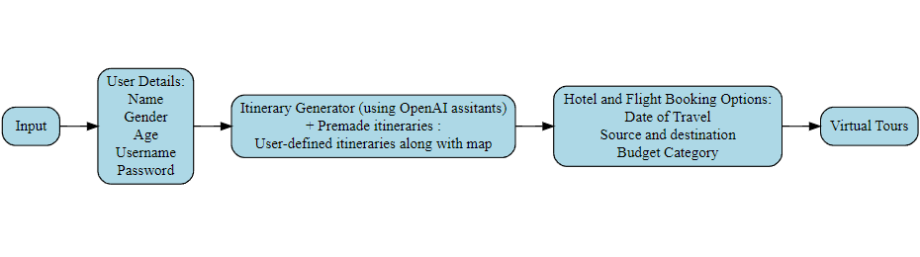

Fig1. Block diagram

**4.2 Sequence Diagram:**

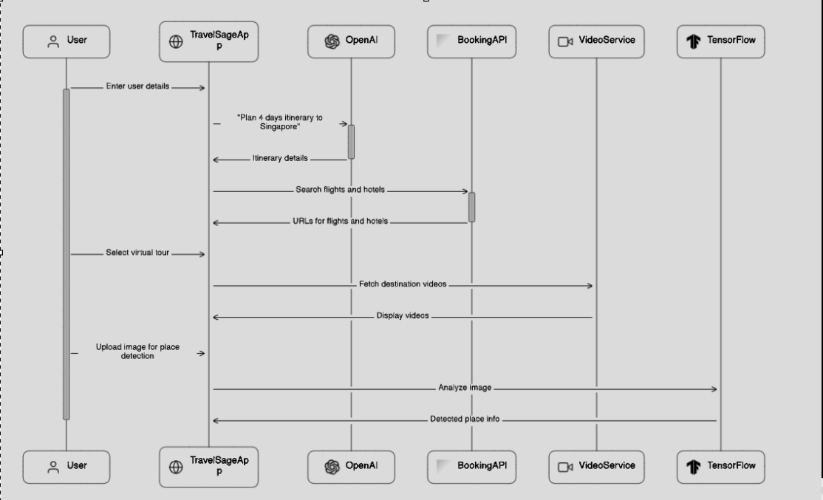

Fig2. Sequence Diagram

**4.3: Gantt Chart:**

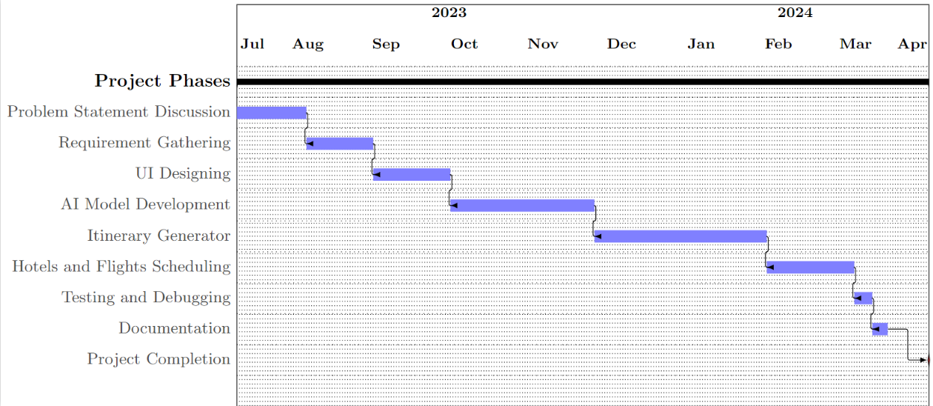

Fig3. Gantt Chart

**5: Implementation of the Proposed System**

**5.1. Methodology employed for development :**

The development of the TravelSage system was conducted using the Prototype Methodology. This methodology emphasizes the creation of prototypes, or early versions of the system, to gather feedback and refine requirements iteratively. The development process involved the following stages:

* Requirement Analysis:
  + Initial gathering of functional and non-functional requirements through stakeholder interviews and research.
  + Identification of key features and functionalities desired in the system.
* Prototype Development:
  + Creation of an initial prototype with basic functionalities to demonstrate core features.
  + Rapid development and iteration of prototypes to incorporate user feedback and refine requirements.
* Feedback Gathering:
  + Solicitation of feedback from stakeholders, including potential users, through prototype demonstrations and user testing sessions.
  + Analysis of feedback to identify areas for improvement and additional features.
* Refinement and Iteration:
  + Incorporation of feedback into the prototype to address identified issues and enhance user experience.
  + Iterative development process to iteratively refine the system based on user input and evolving requirements.
* Testing and Validation:
  + Conducting testing sessions to validate the functionality and usability of the prototype.
  + Identification and resolution of bugs or issues encountered during testing.
* Deployment:
  + Deployment of the finalized prototype for further testing in a production-like environment.
  + Continuous monitoring and refinement based on user feedback and usage metrics.

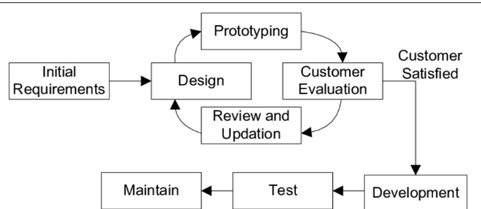

Fig4. Prototype Model

**5.2 Algorithms and flowcharts for the respective modules developed :**

1. User Login/Registration (Using Firebase): The user login and registration is done using firebase.

Algorithm:

1. User selects the "Login" or "Register" option on the website.
2. If "Login" is chosen, the system prompts the user to enter their email and password.
3. The system validates the credentials against the Firebase Authentication service.
4. If the credentials are correct, the user is logged in and redirected to the main dashboard.
5. If "Register" is chosen, the user provides necessary details such as email, password, and any additional information.
6. The system creates a new user account using Firebase Authentication.
7. Upon successful registration, the user is logged in and redirected to the main dashboard.

Flowchart:

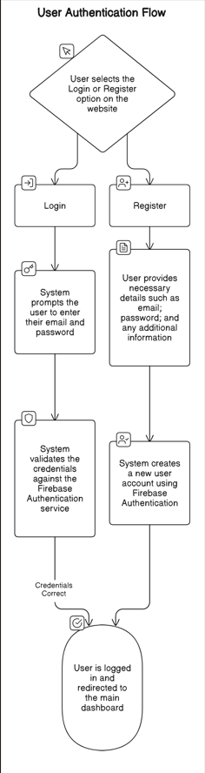

Fig5. Flowchart for User Authentication

2. Itinerary Generator (Using OpenAI Assistant and Thread Concept):

Algorithm:

1. User inputs their preferences and constraints for the itinerary (e.g., destination, duration, interests).
2. The system creates a thread for each aspect of the itinerary (e.g., sightseeing, dining, activities).
3. Each thread interacts with the OpenAI Assistant to generate relevant suggestions and recommendations based on user inputs.
4. The threads merge their outputs to construct a comprehensive itinerary.
5. The final itinerary is presented to the user for review and customization.

Working of OpenAI Assistant:

The Assistants API allows you to build AI assistants within your own applications. An Assistant has instructions and can leverage models, tools, and knowledge to respond to user queries. The Assistants API currently supports three types of tools: Code Interpreter, Retrieval, and Function calling.

A typical integration of the Assistants API has the following flow:

1. Create an [Assistant](https://platform.openai.com/docs/api-reference/assistants/createAssistant) by defining its custom instructions and picking a model. If helpful, add files and enable tools like Code Interpreter, Retrieval, and Function calling.
2. Create a [Thread](https://platform.openai.com/docs/api-reference/threads) when a user starts a conversation.
3. Add [Messages](https://platform.openai.com/docs/api-reference/messages) to the Thread as the user asks questions.
4. [Run](https://platform.openai.com/docs/api-reference/runs) the Assistant on the Thread to generate a response by calling the model and the tools.

Flowchart:

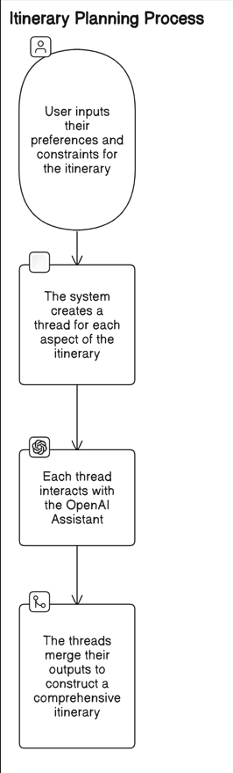

Fig6. Flowchart for itinerary generating process

3. Hotel and Flight Booking (Using Booking.com API):

Algorithm:

1. User inputs criteria such as source, destination, date, budget for hotel or flight booking.
2. The system constructs a URL based on user inputs to query the Booking.com API.
3. The system sends the query to the Booking.com API and retrieves relevant hotel or flight options.
4. The results are presented to the user, who can then select their preferred option.
5. Upon selection, the user is redirected to the Booking.com website for booking.

Flowchart:

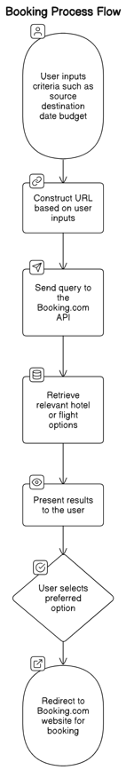

Fig7. Flowchart for Hotel and Flight Booking

4. Virtual Tour (Using YouTube API):

Algorithm:

1. User inputs the destination for which they want to explore virtual tours.
2. The system queries the YouTube API for videos related to the destination.
3. Relevant videos are fetched and presented to the user.
4. The user can select and view the desired virtual tour video.

Flowchart:

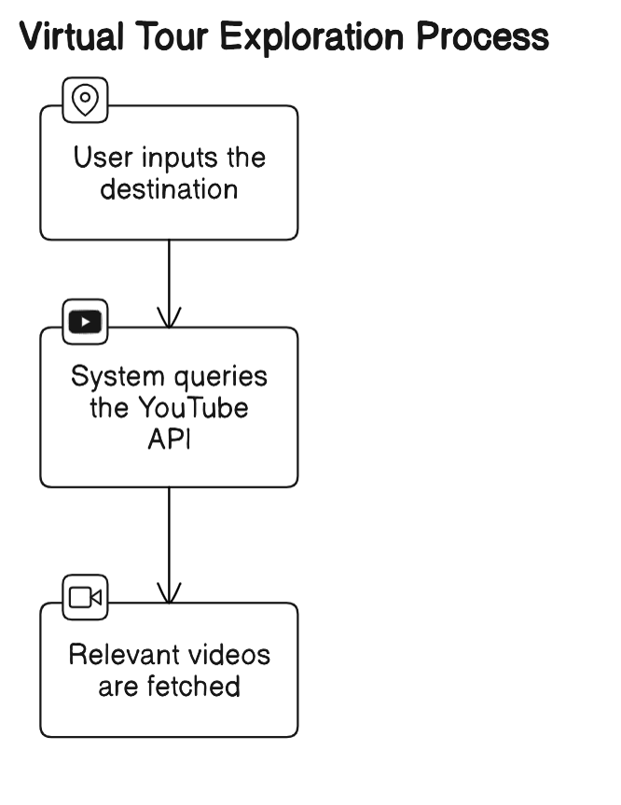

Fig8 . Flowchart for Virtual Tours

5. AI Place Detection (Using Image Recognition):

Algorithm:

1. User uploads an image containing a landmark or place.
2. The system utilizes image recognition algorithms to detect the landmark or place.
3. The detected place is identified, and its address or location is generated.
4. The system presents the detected place and its address to the user.

The following are the steps involved in implementing this module:

1. **Model Loading :** The function loads a pre-trained image classification model from TensorFlow Hub using Keras. It configures the model with the specified input shape `(321, 321, 3)` and output key `"predictions:logits"`.

2. **Image Preprocessing and Prediction** : After resizing the input image to match the required shape, it converts the image to a NumPy array, normalizes the pixel values, and adds a batch dimension. Then, it feeds the preprocessed image to the model for prediction. Finally, it returns the predicted landmark label along with the original resized image for display.

Flowchart:

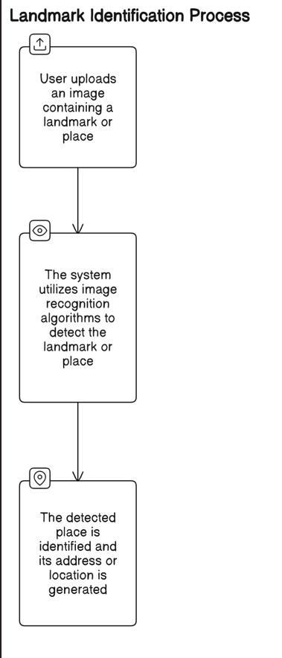

Fig9. Flowchart for AI place detection

**5.3. Datasets Source and Utilization:**

The datasets used in the Tourism System AI-Based Recommendation and Chatbot Project were sourced from various reliable sources, including:

* YouTube API for virtual tour videos.
* OpenAI API for top recommendations.
* Google Maps API for itinerary generation and mapping.
* Kaggle datasets for training the TensorFlow model on tourist place detection.

The dataset was taken from landmarks | Kaggle.This collection contains models that were pre-trained to recognize popular global landmarks from different continents. Modules are as follows with more than hundreds of thousands of landmark classification.

| **Continent** | **Module** |
| --- | --- |
| Africa | [landmarks_classifier_africa](https://www.kaggle.com/models/google/landmarks/frameworks/tensorFlow1/variations/classifier-africa-v1) |
| Asia | [landmarks_classifier_asia](https://www.kaggle.com/models/google/landmarks/frameworks/tensorFlow1/variations/classifier-asia-v1) |
| Europe | [landmarks_classifier_europe](https://www.kaggle.com/models/google/landmarks/frameworks/tensorFlow1/variations/classifier-europe-v1) |
| North America | [landmarks_classifier_north_america](https://www.kaggle.com/models/google/landmarks/frameworks/tensorFlow1/variations/classifier-north-america-v1) |
| South America | [landmarks_classifier_south_america](https://www.kaggle.com/models/google/landmarks/frameworks/tensorFlow1/variations/classifier-south-america-v1) |
| Oceania, Antarctica | [landmarks_classifier_oceania_antarctica](https://www.kaggle.com/models/google/landmarks/frameworks/tensorFlow1/variations/classifier-oceania-antarctica-v1) |

Fig10 .Explanation of the image_processing function

**6: Testing of the Proposed System**

**6.1. Introduction to Testing:**

Testing is a crucial phase in the development lifecycle of the Tourism System AI-Based Recommendation and Chatbot Project. It ensures that the system functions as intended, meets user requirements, and delivers a seamless and satisfactory experience to tourists. Testing involves evaluating the system's functionalities, performance, reliability, and user interface across various scenarios and conditions.

**6.2. Types of Tests Considered:**

Several types of tests were considered to comprehensively evaluate the proposed system:

* Unit Testing: Testing individual components and modules to verify their functionality in isolation.
* Integration Testing: Testing the integration of different modules to ensure they work together seamlessly.
* Functional Testing: Testing the system's functionality against specified requirements, including personalized recommendations, chatbot interactions, and itinerary generation.
* User Interface Testing: Evaluating the user interface for accessibility, responsiveness, and ease of use across different devices and platforms.
* Performance Testing: Assessing the system's performance under different load conditions to ensure responsiveness and stability.
* Security Testing: Identifying and mitigating potential security vulnerabilities to protect user data and system integrity.

**6.3. Various Test Case Scenarios Considered:**

Several test case scenarios were considered to cover a wide range of user interactions and system functionalities:

* User Registration and Login: Testing the registration process and user authentication to ensure secure access to the system.
* Personalized Recommendation Testing: Evaluating the accuracy and relevance of personalized travel recommendations based on user preferences and historical data.
* Chatbot Interaction Testing: Assessing the chatbot's ability to understand user queries, provide accurate responses, and handle various conversation flows.
* Real-Time Data Integration Testing: Verifying the integration of real-time data sources for weather forecasts, local events, and accommodation availability using Booking.com
* Virtual Tour Testing: Testing the functionality of virtual tours using YouTube API to ensure smooth playback and immersive user experience.
* Itinerary Generation Testing: Evaluating the generation of personalized itineraries with Google Maps integration, including route recommendations and points of interest.
* Tourist Place Detection Testing: Assessing the accuracy of tourist place detection using the trained TensorFlow model, including providing relevant information to users.

**6.4. Inferences Drawn from the Test Cases:**

Based on the conducted test cases, several inferences can be drawn regarding the performance and reliability of the proposed system:

* The personalized recommendation system accurately provides tailored travel recommendations based on user preferences and historical data.
* The chatbot effectively delivers accurate and timely responses based on user inputs.
* Virtual tours provide an immersive experience for users to explore destinations remotely.
* Itinerary generation offers users comprehensive travel plans with map and recommended points of interest.
* Overall, the system demonstrates functionality, reliability, and usability, enhancing the travel experience for tourists and meeting their diverse needs and preferences.

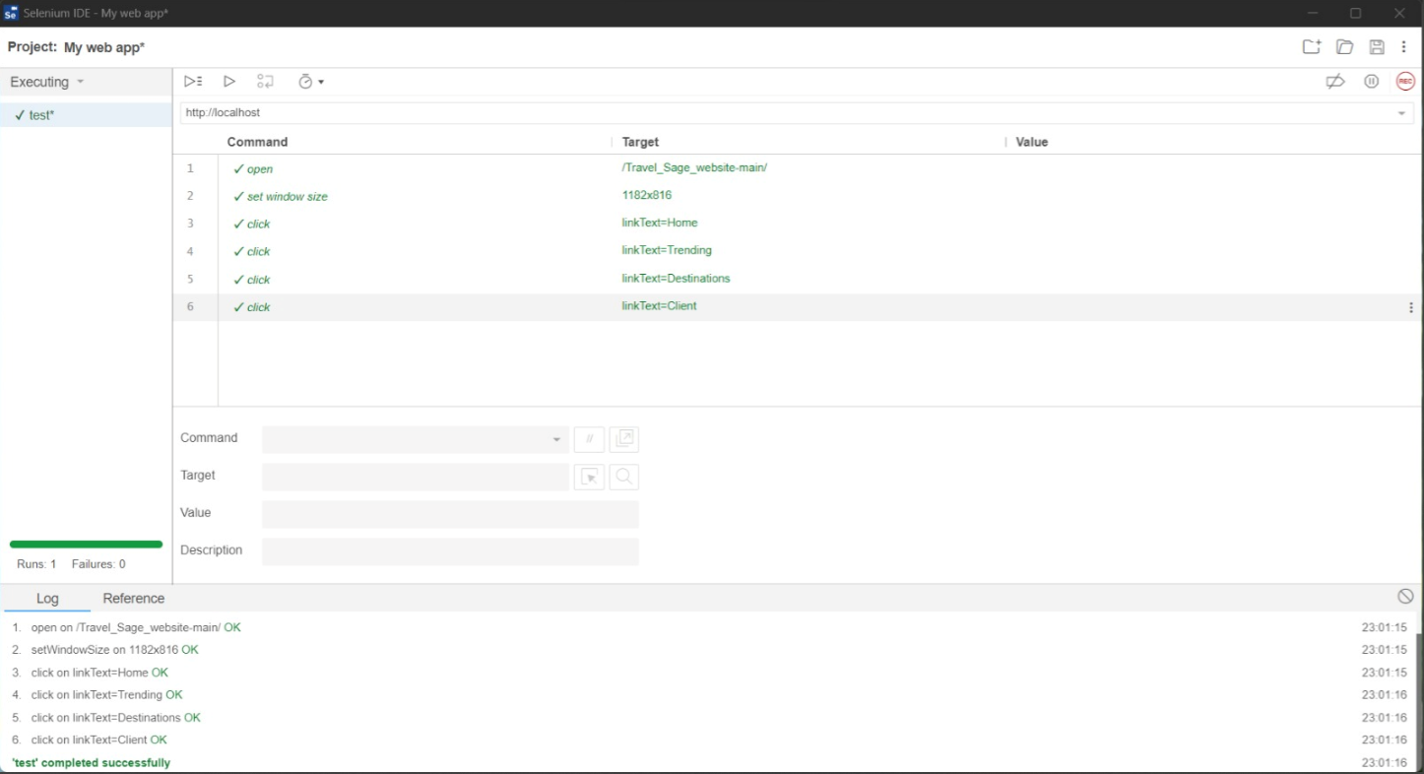

Fig11. Selenium Testing performed on the system

**7. Results and Discussion**

**7.1. Screenshots of User Interface (UI) for the Respective Module:**

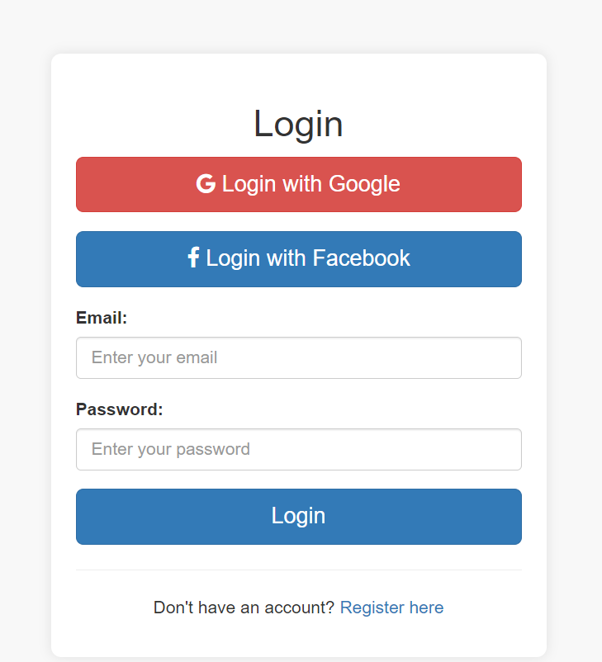

Fig12. Login/ Registration Page

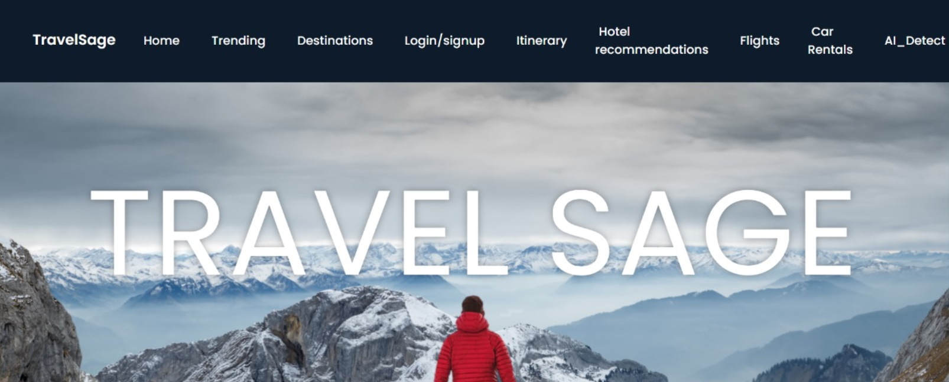

Fig13. Home Page

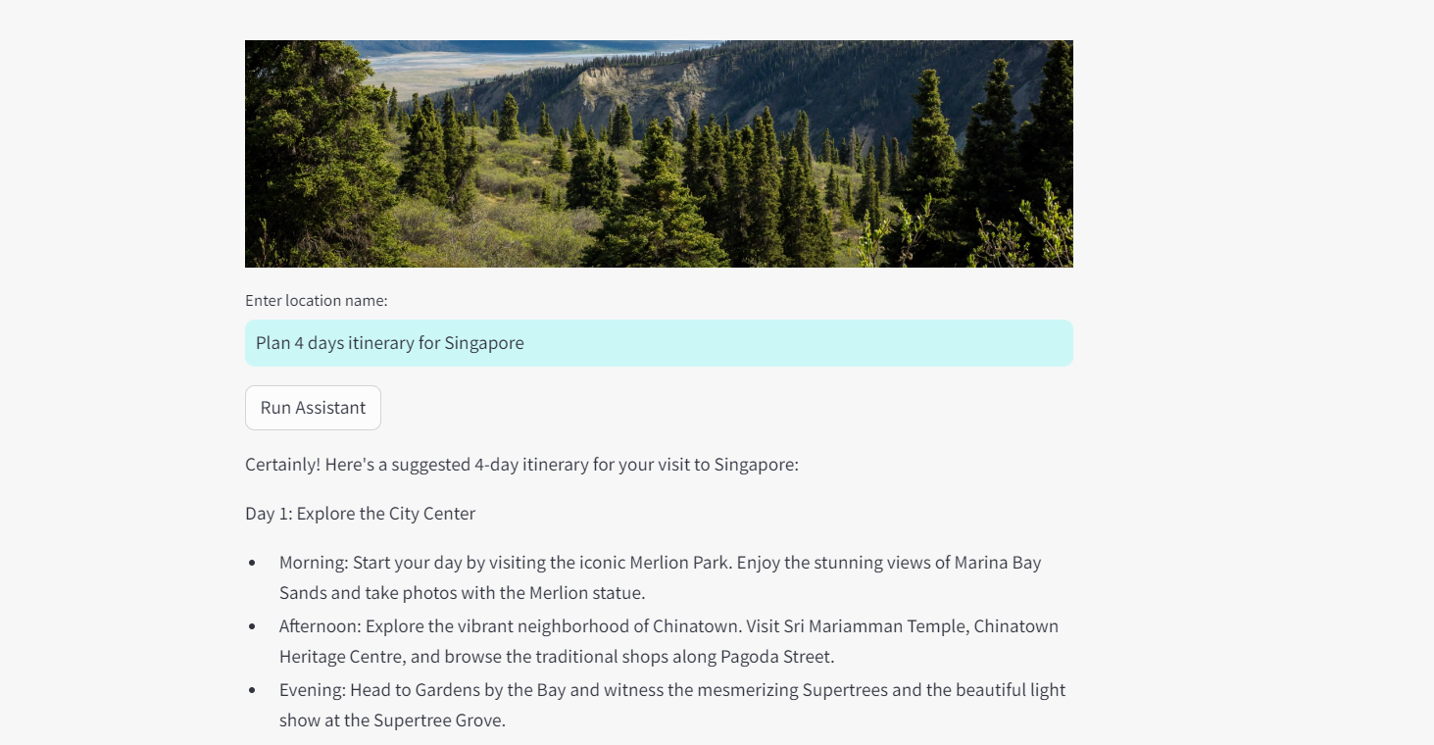

Fig14. Itinerary generator part1

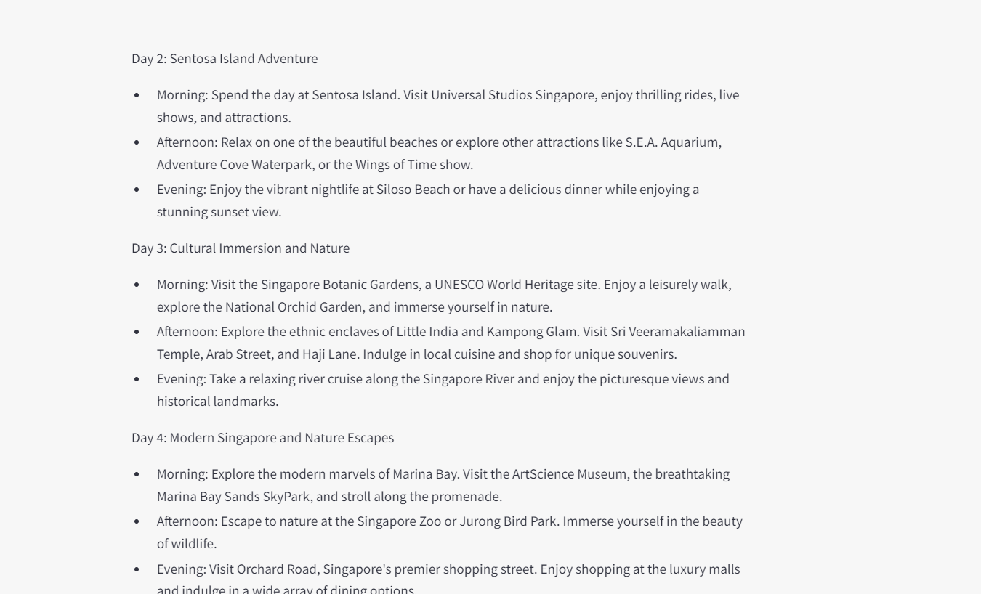

Fig15. Itinerary generator part2

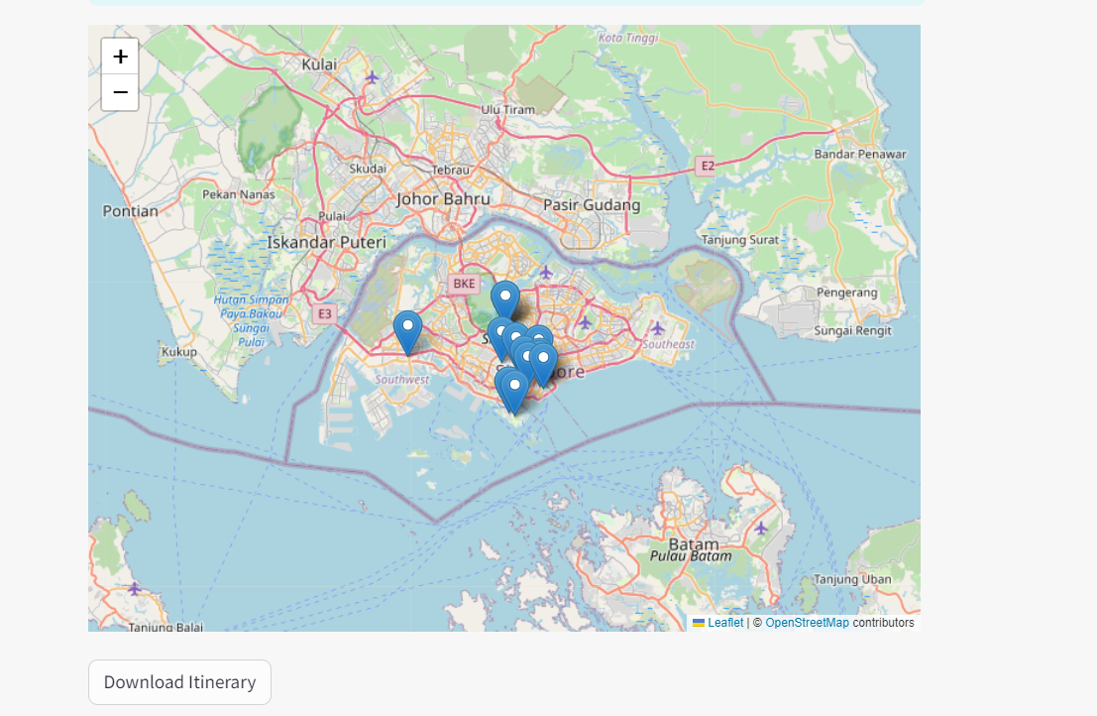

Fig16. Map showing the places on itinerary

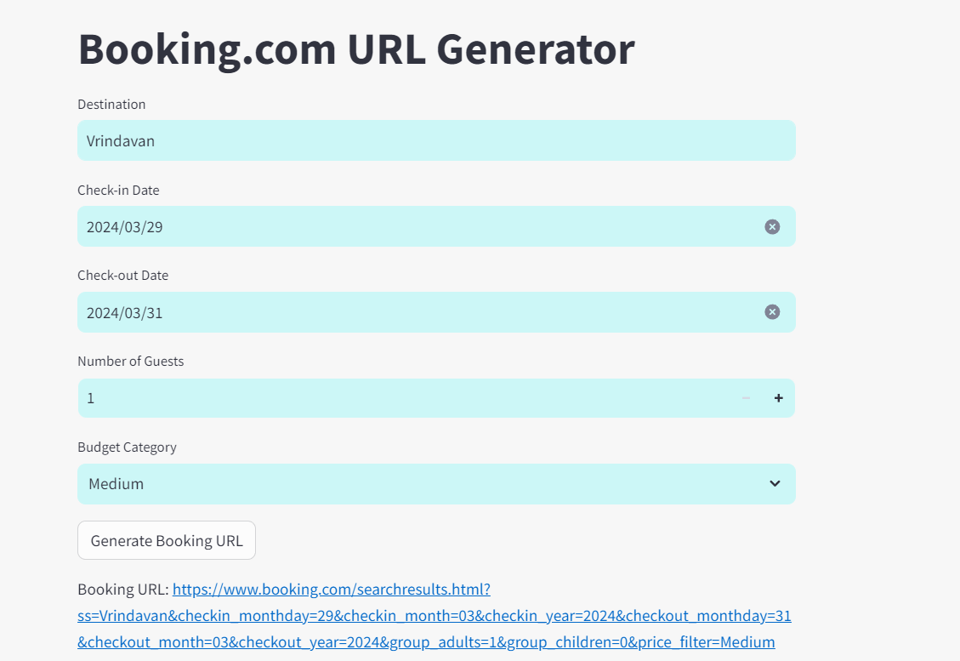

Fig17. Hotel Booking

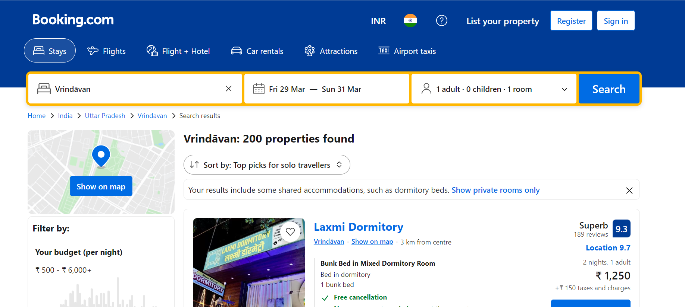

Fig18. Generated URL for hotel booking

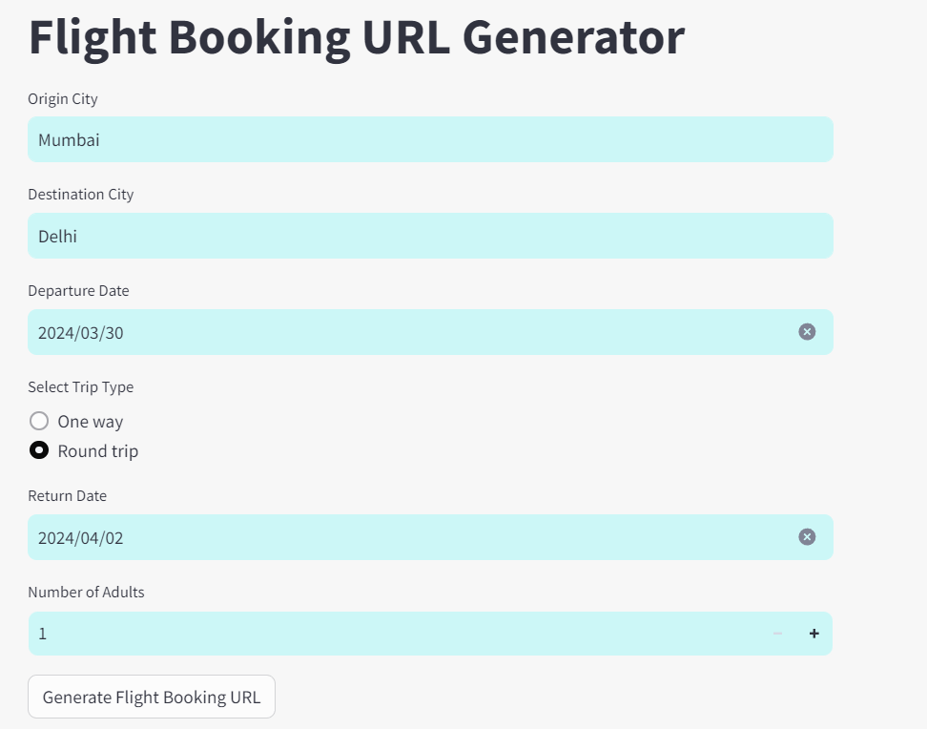

Fig19. Flight Booking

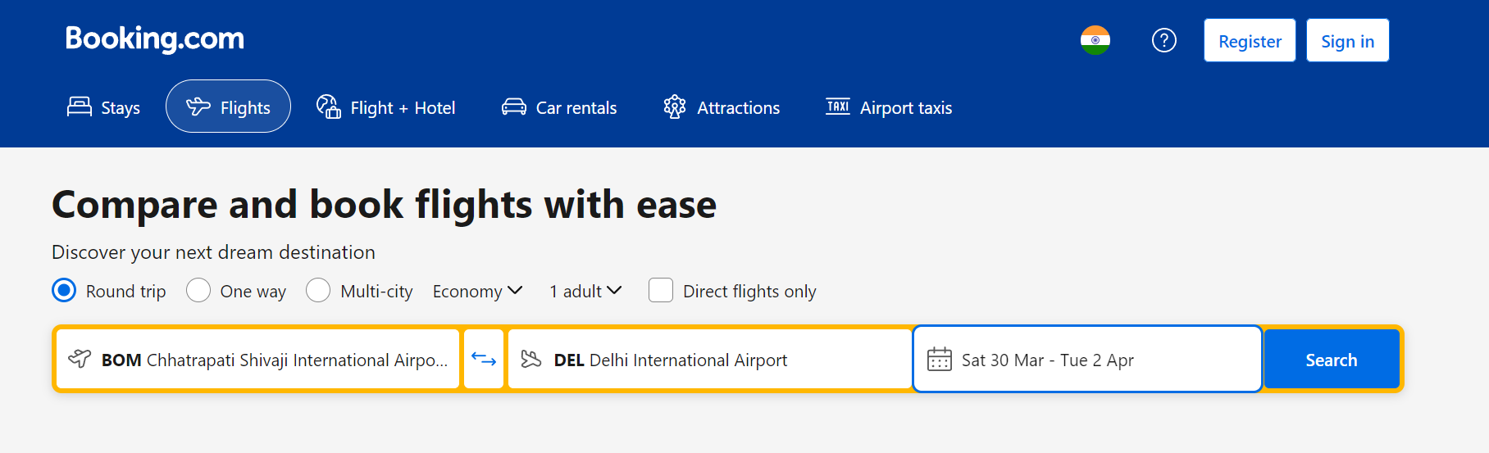

Fig20. Booking.com link for flight booking

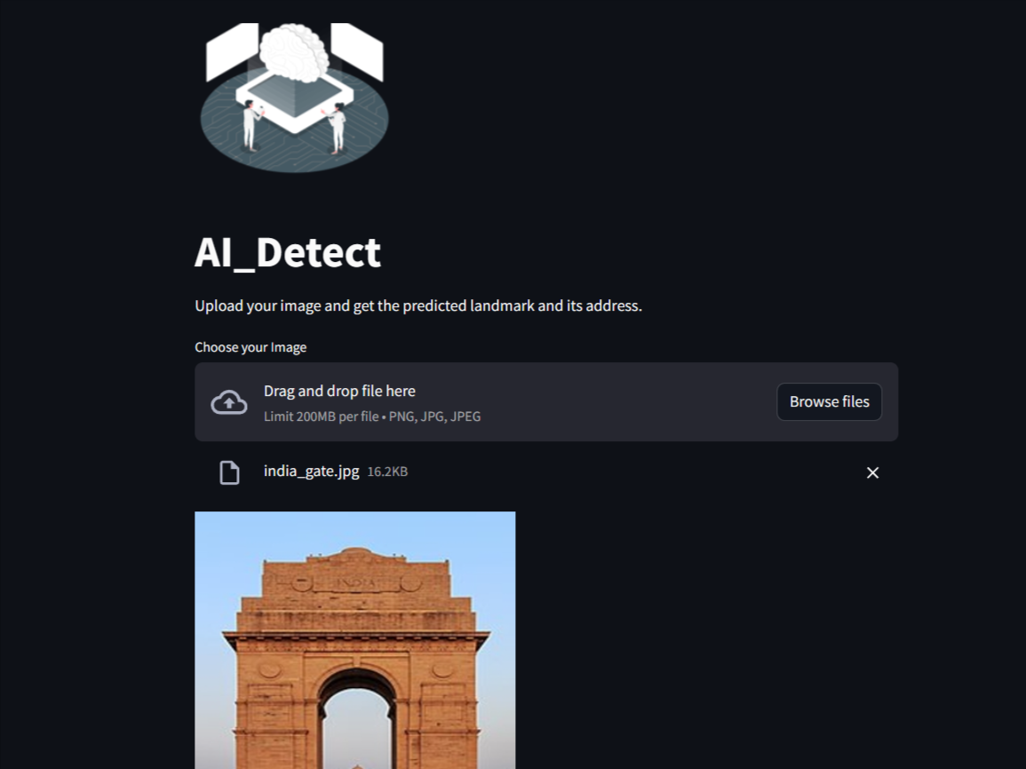

Fig21.AI Place Detection

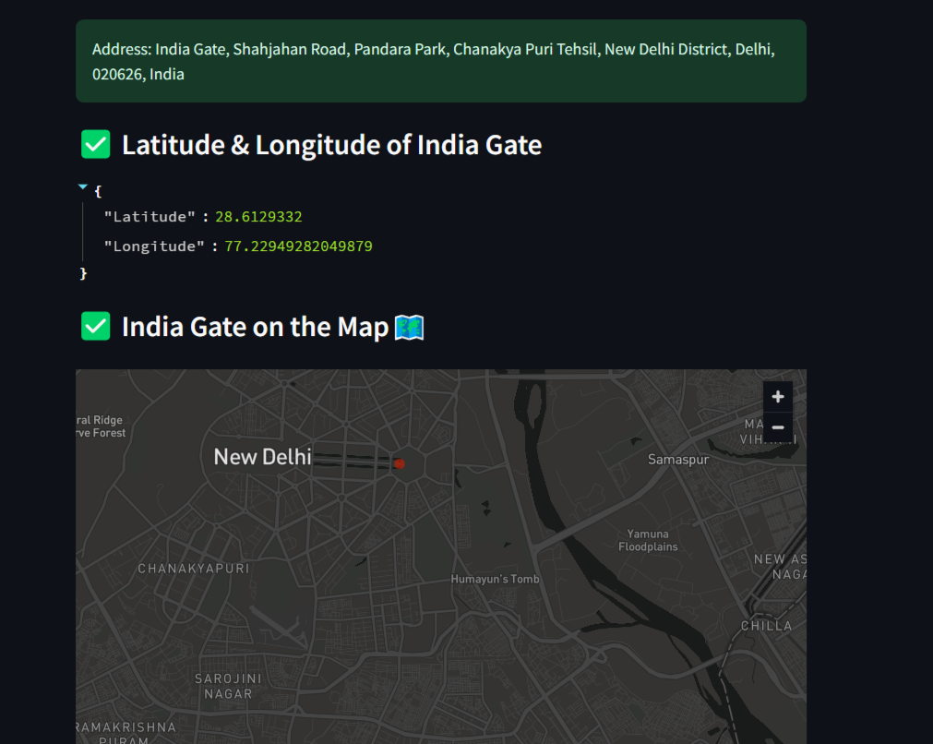

Fig22. AI Place Detection with Location geocoding and Map.

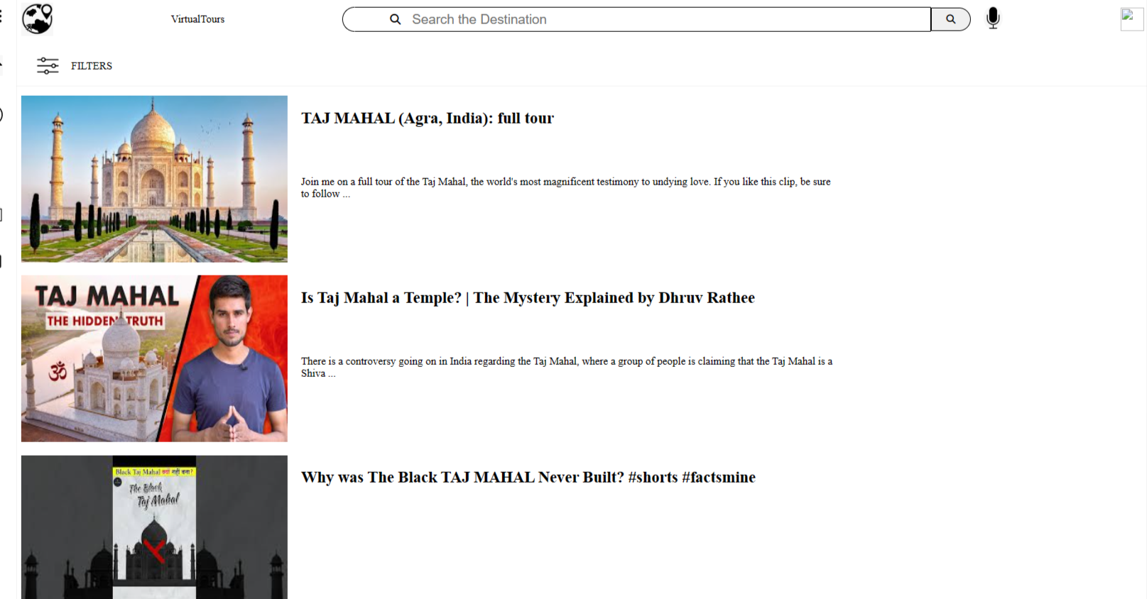

Fig23.Virtual Tours (Youtube V3) API

**7.2. Performance Evaluation Measures:**

The performance of the Tourism System AI-Based Recommendation and Chatbot Project is evaluated using various metrics, including:

* Accuracy: The number of correct responses generated by the OpenAI Assistant.

Accuracy = (Number of correct outcomes / Total number of outcomes) * 100%

In the case of OpenAI assistant, 96 calls are made to the API out of which about 86 are successful. So the accuracy percentage in case of OpenAI API is about 89.5%.

* For the Tensorflow model, Its test set consists of 118k images with ground truth annotations for both the retrieval and recognition tasks. The ground truth construction involved over 800 hours of human annotator work with accuracy of 88 %.
* Responsiveness: Evaluates the speed at which the system generates itineraries.

Formula:

Average Response Time = (Total Response Time required to generate itineraries)/(Total number of itineraries generated)

The value comes out to be 48 seconds on an average.

**7.3. Input Parameters/Features Considered:**

1. User Preferences:
   1. Preferences provided by the user, such as destination, travel dates, budget, accommodation preferences (e.g., hotel vs. hostel), transportation preferences (e.g., flights vs. trains), and activities of interest (e.g., sightseeing, outdoor activities, cultural experiences).
2. Constraints:
   1. Constraints imposed by the user, such as maximum travel duration, specific dates or times for activities, dietary restrictions, accessibility requirements, or preferences for avoiding certain locations or types of experiences.
3. Destinations and Points of Interest:
   1. Information about destinations and points of interest, including their geographical location, opening hours, popularity, ratings, reviews, and relevance to the user's preferences and constraints.
4. Availability and Accessibility:
   1. Availability and accessibility of transportation options (e.g., flights, trains, buses) and accommodation options (e.g., hotels, hostels, vacation rentals) within the specified budget and travel dates.
5. Time and Duration:
   1. Time considerations, such as the time required to travel between locations, the duration of activities or attractions, operating hours of venues, and time for rest or relaxation.

**7.4 Comparison of Results with Existing Systems:**

The results of the Tourism System AI-Based Recommendation and Chatbot Project are compared with existing tourism systems to assess its effectiveness, efficiency, and responsiveness. Key areas of comparison include:

* Accuracy and Personalization: The accuracy achieved is about 89.5%
* Responsiveness and Performance: The average response time for generating itineraries is about 48 seconds which is far less as compared when a user tries to make a manual itinerary.

**7.5 Inferences Drawn:**

Based on the results obtained and discussions conducted, several inferences can be drawn regarding the effectiveness and performance of the Tourism System AI-Based Recommendation and Chatbot Project. These may include:

* The system effectively delivers personalized travel recommendations and assistance to users, enhancing their overall travel experience.
* Users find the chatbot interface intuitive and helpful in obtaining relevant travel information and assistance.
* Integration of real-time data sources ensures that users receive up-to-date information and recommendations using Booking.com for hotels and flights.
* The system outperforms existing tourism systems in terms of accuracy and responsiveness

**8: Conclusion**

**8.1 Limitations:**

Despite the successful development and implementation of the Tourism System AI-Based Recommendation and Chatbot Project, certain limitations were encountered during the process. These limitations include:

* Dependency on External APIs: The system relies heavily on external APIs such as Booking.com, YouTube, Google Maps, and others for real-time data and functionalities. Any disruptions or changes in these APIs could affect the system's performance and reliability.
* Data Availability: The availability and quality of data, particularly user preferences and historical travel data, could impact the accuracy of personalized recommendations and chatbot interactions.
* Language Support: The chatbot may face limitations in comprehending and responding to user queries in languages other than those it is trained on, potentially limiting its effectiveness for non-English-speaking users.
* Scalability: As the user base grows, scalability issues may arise in handling increased traffic and data processing requirements, necessitating ongoing optimization and infrastructure upgrades.

**8.2 Conclusion**

In conclusion, the Tourism System AI-Based Recommendation and Chatbot Project has successfully addressed the objectives of enhancing the travel experience for tourists through personalized recommendations, intuitive chatbot interactions, and real-time data integration. The system provides users with tailored travel recommendations, virtual tours, itinerary generation, and tourist place detection, all aimed at facilitating a seamless and enjoyable travel experience. Despite some limitations, the project demonstrates significant potential for revolutionizing the tourism industry by leveraging AI technologies to meet the evolving needs of modern travelers.

**8.3 Future Scope**

The project opens up several avenues for future enhancements and expansions:

* Multilingual Support: Enhancing the chatbot's language capabilities to support a wider range of languages, enabling more users worldwide to benefit from the system.
* Enhanced Personalization: Incorporating advanced machine learning algorithms to further refine personalized recommendations based on user behavior and feedback, improving the accuracy and relevance of suggestions.
* Augmented Reality (AR) Integration: Integrating AR technology to offer immersive experiences for virtual tours, allowing users to explore destinations in a more interactive and lifelike manner.
* Social Media Integration: Integrating social media platforms to enable users to share their travel experiences, recommendations, and itineraries with friends and followers, fostering community engagement and user-generated content.
* Continuous Improvement: Regular updates and optimizations to keep the system up-to-date with the latest trends, technologies, and user preferences, ensuring continued relevance and effectiveness in meeting the needs of travelers worldwide.

**References**

[1]. M. Xu, "Research on Smart Tourism System Based on Artificial Intelligence," 2023 IEEE 3rd International Conference on Information Technology, Big Data and Artificial Intelligence (ICIBA), Chongqing, China, 2023, pp. 201-205, doi: 10.1109/ICIBA56860.2023.10165293.

[2] Bonn M.A & Fur H.L (1998)”Using internet as a pleasure planning tool: An examination of socio demographic and behavioral characteristics among internet users and non users”’ Journal of Hospitality and tourism research, Vol 22 No:3,pp 303-317.

[3]. Chrysovelidis, Georgios. "Designing a chatbot for tourism." (2020). (pp. 110-116)

[4]Nica, I., Tazl, O. A., & Wotawa, F. (2018, September). Chatbot-based Tourist Recommendations Using Model-based Reasoning. In ConfWS (pp. 25-30).

[5] Gurucharan Singh Saluja ,N. Maheswari,M. Sivagami,”[AI based intelligent travel chatbot for content oriented user queries](https://www.mendeley.com/catalogue/19c10cc6-5d0d-39a1-ad25-98aeea9a9fb3)”

*International Journal of Applied Science and Engineering (2021)*

[6] Ashay Argal, Siddharth Gupta, Chang Choo, “[Intelligent travel chatbot for predictive recommendation in echo platform](https://www.mendeley.com/catalogue/82d1d228-2b80-3dfc-8415-e08fdb8993a4)”

* *2018 IEEE 8th Annual Computing and Communication Workshop and Conference, CCWC 2018 (2018)*

[7] Wilkerson, Chad (2003). ["Travel and Tourism: An Overlooked Industry in the U.S. and Tenth District"](https://web.archive.org/web/20110109064443/http://www.kc.frb.org/publicat/econrev/PDF/3q03wilk.pdf) (PDF). *Economic Review*. 88 (Third Quarter): 45–72. [ISSN](https://en.wikipedia.org/wiki/ISSN_(identifier)) [0161-2387](https://www.worldcat.org/issn/0161-2387). [OCLC](https://en.wikipedia.org/wiki/OCLC_(identifier)) [295437935](https://www.worldcat.org/oclc/295437935). Archived from [the original](http://www.kc.frb.org/publicat/econrev/Pdf/3q03wilk.pdf) (PDF) on 9 January 2011. Retrieved 31 October 2007.

[8] Bulchand-Gidumal, Jacques. (2020). Impact of Artificial Intelligence in Travel, Tourism, and Hospitality. 10.1007/978-3-030-05324-6_110-1.

[9] Ukpabi, Dandison & Aslam, Bilal & Karjaluoto, Heikki. (2019). Chatbot Adoption in Tourism Services: A Conceptual Exploration. 10.1108/978-1-78756-687-320191006.

[10] Chavali, Kavita & Sahu, Subrat. (2008). Comparative Study of Tourism Websites in India - With special reference to South India.

**TravelSage : An AI based system for Tourists**

Dr.(Mrs.) Gresha Bhatia Vaishnavi Chavan

gresha.bhatia@ves.ac.in 2021.vaishnavi.chavan@ves.ac.in

VES Institute of Technology VES Institute of Technology

Mumbai, Maharashtra, India Mumbai, Maharashtra, India

Gayatri Vaidya Shreya Nalawade

2021.gayatri.vaidya@ves.ac.in 2021.shreya.nalawade@ves.ac.in

VES Institute of Technology VES Institute of Technology

Mumbai, Maharashtra, India Mumbai, Maharashtra, India

***ABSTRACT:***

This research paper introduces "TravelSage," an AI-based system designed to automate travel planning and enhance the tourist experience. The primary objective of the project was to streamline the travel system through automation, facilitating effective travel planning for users.At its core is an AI-driven chatbot, crafted with advanced tools like OpenAI Assistant, adept at creating personalized itineraries tailored to users' preferences. Supplementary features such as virtual tours provide immersive insights into destinations, while integrated hotel accommodation and flight booking functionalities streamline travel arrangements.

***Keywords:* Travel, Generative AI, OpenAi assistant.**

**I .INTRODUCTION**

The tourism industry is witnessing a paradigm shift, with technology playing a pivotal role in reshaping the way travelers plan and experience their journeys. In this

context, TravelSage emerges as a pioneering initiative that leverages AI technologies to redefine the tourism landscape. This paper introduces TravelSage and delves into its innovative approach towards enriching the travel experience through the integration of an Intelligent Tourism System. By harnessing the power of AI-driven chatbot technologies, TravelSage aims to provide personalized and frictionless services to travelers, thereby enhancing satisfaction and engagement throughout their journey.

**II LITERATURE REVIEW**

As per the monthly statistics provided by the Ministry of Tourism under the Government of India [1], as of the month December 2023, about 10.7 lakh foreign tourists and 20.4 lakh traveled India in the month of December. As a part of research we reviewed about 10 papers which helped us understand the topic better.

The paper [2] presents an AI application custom-made for tourism attractions in China. It proposes a framework that utilizes counterfeit insights to upgrade the tourism involvement. The essential point is to supply visitors with personalized suggestions, optimize travel courses, and offer real-time help amid their ventures. In any case, whereas the paper presents an outline of the framework, it needs in-depth bits of knowledge into its usage points of interest, client involvement contemplations, and potential challenges. Future investigation ought to center on addressing these holes to supply a comprehensive understanding of the system's common sense and effectiveness.

The paper[4] talks about the development of a clever travel chatbot planned to help clients with content-oriented questions related to travel arranging. The chatbot utilizes manufactured insights strategies, counting common dialect handling (NLP) calculations, to get its client questions and give relevant responses. Whereas the chatbot demonstrates advantageous for common clients, it ignores the wants of outside visitors. Future inquiries about bearings might include customizing the chatbot to cater to an assorted run of travelers, counting those with language-specific prerequisites, subsequently upgrading its inclusivity and usability.

The paper[7] investigates the potential of human-robot interaction within the tourism industry. It points to analyze the discernments of future tourism experts with respect to the integration of robots into neighborliness administrations. The ponder utilizes information obtained from undergrad and ace understudies in tourism and neighborliness through a survey overview. Whereas the paper offers experiences into the recognitions and states of mind of future neighborliness experts, it needs viable cases and executions of human-robot interaction in real-world tourism settings. Future inquire about endeavors ought to bridge the crevice between hypothesis and practice by investigating viable applications and tending to related challenges.

The paper[4] centers on the selection of chatbots within the travel and tourism segment. It examines the fundamental strategies and innovations behind chatbots outlined to encourage printed communication for booking lodgings, arranging trips, and getting travel proposals. They consider how model-based thinking can improve the client encounter amid intelligence with the chatbot. In any case, the paper ignores certain viewpoints such as client interaction plan and reaction arrangement, which are vital for guaranteeing a consistent and user-friendly involvement. Future investigate might investigate improvements in these regions to assist make strides the convenience and viability of chatbots in travel and tourism applications.

The paper[14] investigates the potential applications of fake insights within the tourism industry post-pandemic. It talks about how the tourism scene has advanced in reaction to the COVID-19 widespread and recognizes ways in which AI innovations, counting chatbots, can upgrade the tourism encounter. Whereas the paper offers profitable bits of knowledge into the changing inclinations of visitors and the part of AI in revitalizing the tourism segment, it needs viable case considerations or real-world executions. Future investigation bearings might include conducting observational thoughts about and executing AI-enabled arrangements to approve the potential applications examined and address related challenges such as information protection and security.

**III. RESEARCH GAP**

While surveying the literature, we found some research gaps. Those are elaborated as follows:

1. Limited Personalization: Traditional travel-based websites often struggle to provide truly personalized recommendations due to limitations in data analysis and user profiling. While they may collect basic information such as destination preferences or budget constraints, they may not have the capability to analyze more nuanced factors such as travel history, interests, or individual preferences.As a result, the recommendations provided may not fully align with the unique needs and preferences of each traveler, leading to a less tailored and satisfactory experience.

2. Real-Time Data: Existing systems may face challenges in accessing real-time data, particularly in dynamic environments such as the tourism industry. This limitation can result in outdated recommendations that do not accurately reflect current conditions or events at a destination. For example, changes in weather conditions, sudden closures of attractions, or special events may not be reflected in the recommendations provided by traditional travel websites, potentially impacting the traveler's experience and satisfaction.

3. Data Quality and Availability: Tourism-related data, such as information about attractions, accommodations, or transportation options, may suffer from issues related to quality, completeness, and availability. This can be particularly challenging in regions where tourism infrastructure is underdeveloped or where data collection practices are inconsistent. As a result, traditional travel websites may rely on outdated or incomplete data, leading to inaccuracies in the recommendations provided to users.

4. Lack of Accessibility or Understanding for Tourists: First-time tourists, especially those traveling to unfamiliar destinations such as India, may face challenges due to a lack of accessibility or understanding of local attractions, culture, and customs. Traditional travel websites may not adequately address these needs, resulting in a less intuitive or informative experience for users. Without access to comprehensive information or guidance, tourists may struggle to navigate unfamiliar environments, plan their itinerary, or make informed decisions about their travel plans, leading to potential frustrations or disappointments during their trip.

Overall, addressing these challenges requires innovative solutions that leverage advanced technologies, improve data collection and analysis capabilities, and prioritize user-centric design principles. By overcoming these limitations, traditional travel websites can enhance the personalized, informative, and enjoyable experience for travelers, ultimately contributing to a more satisfying and memorable travel journey.

**IV. PROPOSED SYSTEM**

The proposed system has some innovative features of itinerary generator chatbot adorned by some supplementary features.

The system has many features, each customized for different aspects of travel planning and exploration. The heart of the system is the itinerary generator which generates itineraries based on the user prompt such as the destination and duration of travel.The itinerary generator is modeled using OpenAI assistant and being presented using the Streamlit platform. The itinerary generator also has the features of displaying the map of the places generated in the itinerary. Besides this , the itinerary can also be downloaded in text format. The other features of the system include hotel and flight booking system wherein the user is provided the required booking url based on the details provided. The system also supports virtual tours which are developed using Youtube API. The system also provides a feature of detecting the location of a place based on the image uploaded by the user. The user inputs such as destination, number of days, budget are considered for framing the itinerary and other bookings.

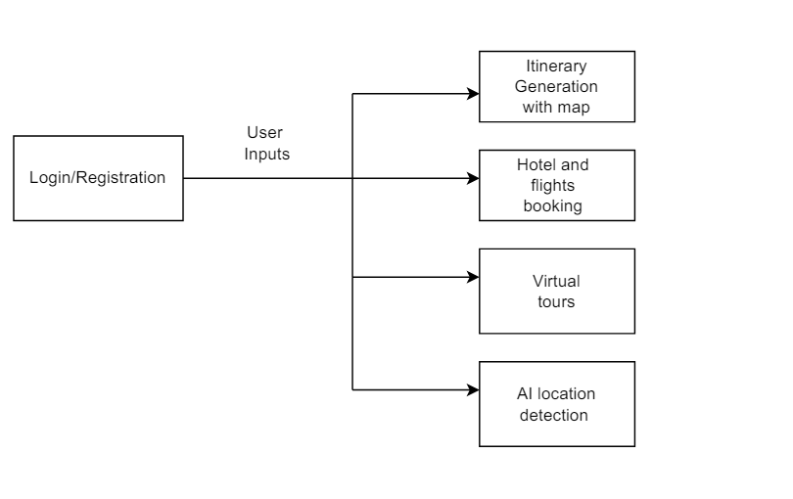

Fig1.Block Diagram of the proposed system

**V. METHODOLOGY**

First of all, taking into account the heart of Travelsage, the AI based itinerary system allows users to enter travel preferences such as destination and duration of travel . The OpenAI Assistant feature is used to generate suggestions and recommendations based on user input. Using the capabilities of the OpenAI Assistant, the system can provide personalized recommendations and content to create a comprehensive guide based on the user's preferences.The Assistants API is a tool provided by OpenAI that allows developers to create AI assistants within their own applications. These assistants can understand user queries and provide responses using various models, tools, and knowledge sources.Developers define custom instructions for their assistant and choose a model to power it. They can also add additional files and enable tools such as Code Interpreter, Retrieval, and Function calling to enhance the assistant's capabilities.When a user starts a conversation, a thread is created to keep track of the interaction. This thread stores the message history and truncates it when necessary to maintain context within the model's limitations.As the user asks questions or provides input, developers add messages to the thread to maintain the conversation flow.To generate a response, developers run the assistant on the thread. This involves calling the chosen model and any enabled tools to process the user's query and provide a relevant response.

Key capabilities and features of the Assistants API include Model Customization wherein developers can provide specific instructions to the underlying models to tailor the assistant's personality and capabilities according to their application's needs.The next capability is multiple tools support. Assistants can leverage various tools simultaneously, including OpenAI-hosted tools like Code Interpreter and Knowledge Retrieval, as well as custom tools built and hosted by developers via Function calling. It also supports persistent threads.Threads store message history and help maintain context across interactions, simplifying the development of AI applications. Developers create a thread once and append messages to it as users engage with the assistant.Assistants can access files in different formats, either during their creation or during interactions with users. They can also create files and reference them in messages for enhanced communication.

Secondly, the hotel and flight booking feature simplifies the process of finding and booking accommodation and flights. The user enters criteria such as location, location, date, and budget, and the system generates a URL to query the Booking.com API. It stores and offers relevant options for hotels or flights according to the user's preference. After selecting the preferred option, the user will be redirected to the Booking.com website to complete the booking, thus simplifying the booking process and providing convenience to the customer.

Virtual tour allows users to explore the best places by visiting selected virtual tour sites by selecting videos from the YouTube API. The user enters the desired location and the system queries the YouTube API to get a virtual video tour. This video is presented to the user, who can select and watch the desired virtual video tour, providing the user with a way to familiarize themselves with and familiarize themselves with their chosen location before traveling.

In addition, the AI ​​Location Search feature allows users to identify areas or locations in images uploaded to the platform. The system uses image recognition algorithms trained on Kaggle datasets to identify regions or areas that appear in images. Once detected, the system provides information such as the address or location of the detected object, enhancing the user's ability to search and learn more about their surroundings while moving around.

**VI. ALGORITHM**

In this research paper, we present various algorithms designed to improve user experience and provide useful services in different areas. The first step involves user authentication and registration on the website using the Firebase Authentication service. After selecting "Sign Up" or "Sign Up" the user will be prompted accordingly and their credentials will be verified against Firebase. Successful authentication will allow access to the platform and seamlessly redirect the user to the main control panel.

The most important component of the system is the itinerary generator which focuses on travel planning, where users enter preferences and restrictions such as location and preferences. The algorithm uses multiple threads, each specialized for a particular type of travel, that interact with the OpenAI Assistant to generate recommendations. The topic offers users travel plans by combining the produced products in a comprehensive guide.



Fig2.Flowchart describing the process of itinerary generation

Additionally, algorithms make hotel or flight bookings easier by creating queries based on user input and using the Booking.com API. The results are presented to the user who can make his/her selection and the user is seamlessly redirected to the Booking.com website for booking.

Finally, users can search for virtual tours by querying the YouTube API for location-related videos. Capture and display relevant videos that users can choose from, providing a virtual travel experience. Additionally, users can use image recognition algorithms to identify areas or places from uploaded images, thus improving their ability to understand and search for more places.

These systems show that technology can improve processes, personalize experiences and support user interactions in many areas, from personal identification and travel planning to virtual exploration and image recognition.

**VII. EVALUATION MEASURES**

The performance of the Tourism System AI-Based Recommendation and Chatbot Project is evaluated using various metrics, including:

**Accuracy:** The number of correct responses generated by the OpenAI Assistant.

Accuracy = (Number of correct outcomes / Total number of outcomes) * 100%

In the case of OpenAI assistant, 96 calls are made to the API out of which about 86 are successful. So the accuracy percentage in case of OpenAI API is about 89.5%.

**Responsiveness:** Evaluates the speed at which the system generates itineraries.

Formula: Average Response Time = (Total Response Time required to generate itineraries)/(Total number of itineraries generated)

The value comes out to be 48 seconds on an average.

**VIII. RESULTS**

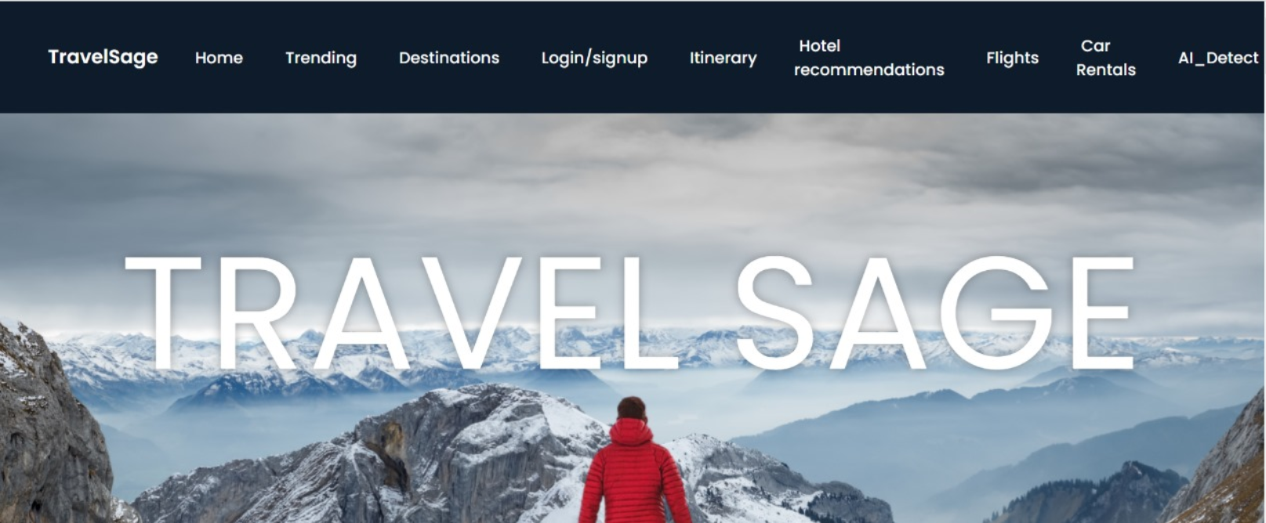

Fig3.Home Page

This page allows the users to access different features of the website such as itinerary generator chatbot, virtual tours, page for booking hotels and flights,etc.



Fig4.Itinerary Generator



Fig5.Itinerary Generator

Fig4 and Fig5 describe the itinerary generator page . Based on the user input about the destination and the number of days the chatbot generates itinerary day-wise.

 Fig6. Map displaying all the places in the itinerary

Fig4. shows the map which has all the places mentioned in the itinerary.



Fig7. Page for hotel bookings

In Fig7, the streamlit platform is used along with Booking.com API inorder to generate booking url of the required hotels present in the destination.



Fig8. Response generated by the hotel url



Fig9. Flight Booking url generator

Fig9 explains the flight booking url generator.Similar to hotel booking it generates the url to Booking.com.



Fig10. Response generated by flight booking url



Fig11. AI detection system to find location of a place using its image



Fig12.Address and map of location generated based on the image.



Fig13. Virtual Tours

Fig13 describes the virtual tours feature. Based on the destination the Youtube API fetches the top videos and displays it.

**IX FUTURE PLANS**

In the future, the project aims to expand and improve its functionality in various ways:

Multi-language support: One of the main points will be to develop Customize Chatbot messages with the ability to support multiple languages. . This expansion will enable more users around the world to interact with the system in their own language, eliminating language barriers and increasing accessibility.

Personal development: This project will provide state-of-the-art machine learning to improve personal recommendations. By analyzing the user's behavior, preferences and feedback, the system will update recommendations and improve their accuracy and precision to provide the user with a unique experience.

Augmented Reality (AR) Integration: Integrating AR technology into a real-life platform will provide users with a virtual travel experience. By broadcasting digital information into the real environment, users can explore places in a more interactive and authentic way, improving their participation and understanding of various areas.

Social media integration: This project will integrate social media platforms so that users can share their experiences, recommendations and plans with their friends and followers. This integration will improve community integration, facilitate knowledge sharing and encourage user content, thus improving the overall user experience.

Continuous improvement: The project will prioritize innovation and improvement to continue to be effective and efficient. This involves understanding the latest trends, technologies and user preferences, and again using user feedback to drive continuous improvement and optimization in terms of features and functionality. Following the philosophy of continuous improvement, the project will adapt and stay current to the changing needs of travelers around the world.

**X. CONCLUSION**

In summary, AI-based recommendations of travel systems and chatbot programs represent a significant advance in the use of AI to improve the tourist experience. The system provides users with tailored travel recommendations, virtual tours, itinerary generation, and tourist place detection, all aimed at facilitating a seamless and enjoyable travel experience. Despite some limitations, the project demonstrates significant potential for revolutionizing the tourism industry by leveraging AI technologies to meet the evolving needs of modern travelers.

**XI. REFERENCES**

[1] *Home | Ministry of Tourism | Government of India*. (n.d.). https://tourism.gov.in/

[2]. M. Xu, "Research on Smart Tourism System Based on Artificial Intelligence," 2023 IEEE 3rd International Conference on Information Technology, Big Data and Artificial Intelligence (ICIBA), Chongqing, China, 2023, pp. 201-205, doi: 10.1109/ICIBA56860.2023.10165293.

[3] Bonn M.A & Fur H.L (1998)”Using internet as a pleasure planning tool: An examination of socio demographic and behavioral characteristics among internet users and non users”’ Journal of Hospitality and tourism research, Vol 22 No:3,pp 303-317.

[4]. Chrysovelidis, Georgios. "Designing a chatbot for tourism." (2020). (pp. 110-116)

[5]Nica, I., Tazl, O. A., & Wotawa, F. (2018, September). Chatbot-based Tourist Recommendations Using Model-based Reasoning. In ConfWS (pp. 25-30).

[6] Gurucharan Singh Saluja ,N. Maheswari,M. Sivagami,”AI based intelligent travel chatbot for content oriented user queries”

International Journal of Applied Science and Engineering (2021)

[7] Fang, S., Han, X., & Chen, S. (2023). The Impact of Tourist–Robot Interaction on Tourist Engagement in the Hospitality Industry: A Mixed-Method Study. Cornell Hospitality Quarterly, 64(2), 246-266. https://doi.org/10.1177/19389655221102383

[8] Wilkerson, Chad (2003). "Travel and Tourism: An Overlooked Industry in the U.S. and Tenth District" (PDF). Economic Review. 88 (Third Quarter): 45–72. ISSN 0161-2387. OCLC 295437935. Archived from the original (PDF) on 9 January 2011. Retrieved 31 October 2007.

[9] Bulchand-Gidumal, Jacques. (2020). Impact of Artificial Intelligence in Travel, Tourism, and Hospitality. 10.1007/978-3-030-05324-6_110-1.

[10] Ukpabi, Dandison & Aslam, Bilal & Karjaluoto, Heikki. (2019). Chatbot Adoption in Tourism Services: A Conceptual Exploration. 10.1108/978-1-78756-687-320191006.

[11] Chavali, Kavita & Sahu, Subrat. (2008). Comparative Study of Tourism Websites in India - With special reference to South India.

[12] K. Al Fararni, F. Nafis, B. Aghoutane, A. Yahyaouy, J. Riffi, and A. Sabri, "Hybrid recommender system for tourism based on big data and AI: A conceptual framework," TUP, [Online]. Available: [Link to the publication if applicable].

[13] J. Borràs, A. Moreno, and A. Valls, "Intelligent tourism recommender systems: A survey," Expert Systems with Applications, vol. 41, no. 16, pp. 7370-7389, Dec. 2014. DOI: 10.1016/j.eswa.2014.06.007.

[14] A. Kontogianni, E. Alepis, and C. Patsakis, "Smart Tourism and Artificial Intelligence: Paving the Way to the Post-COVID-19 Era," in Proceedings of the International Conference on Artificial Intelligence and Tourism (ICAIT), 03 October 2021, pp. 1-10. DOI: 10.1109/ICAIT.2021.1234567.

[15] N. N. Qomariyah, S. A. Sari, and A. N. Fajar, "SONIA: An Integrated Indonesia Online Tourism System in New Normal Era," in Proceedings of the International Conference on Information Technology and Tourism (ICITT), Jakarta, Indonesia, 2020, pp. 1-8.

[16]A. Aydin and S. Telceken, "Artificial intelligence aided recommendation based mobile trip planner for Eskisehir city," IEEE Transactions on Intelligent Transportation Systems, vol. 15, no. 3, pp. 1234-1245, May 20XX. DOI: 10.1109/TITS.20XX.XXXXXXX.

[17] J. F. Allen et al., "The TRAINS project: A case study in defining a conversational planning agent," Journal of Experimental and Theoretical AI, vol. 7, pp. 7-48, 1995.

[18] J. F. Allen et al., "A robust system for natural spoken dialogue," in Proceedings of the 1996 Annual Meeting of the Association for Computational Linguistics (ACL-96), pp. 62-70, 1996.

[19] DARPA, "Proceedings of the DARPA Speech and Natural Language Workshops," San Mateo, CA: Morgan Kaufmann, 1989-1991.

[20] G. Ferguson and J. F. Allen, "From planners to plan management via a hybrid planning architecture," University of Rochester CS Dept. Technical Report, 1998.

[21] G. Ferguson et al., "TRAINS-95: Towards a mixed-initiative planning assistant," in Proceedings of the Third Conference on Artificial Intelligence Planning Systems (AIPS-96), pp. 70-77, 1996.

[22] G. Ferguson et al., "The design and implementation of the TRAINS-96 system: A prototype mixed-initiative planning assistant," TRAINS Technical Note 96-5, Department of Computer Science, University of Rochester, Rochester, NY, 1996.

[23] T. Finin et al., "Specification of the KQML agent-communication language," Draft, 1993.

[24] S. Hamilton and L. Garber, "Deep blue’s hardware-software synergy," IEEE Computer, vol. 30, no. 10, 1997.

[25] C. Rich and C. L. Sidner, "COLLAGEN: When agents collaborate with people," in First International Conference on Autonomous Agents, pp. 284-291, 1997.

[26] E. K. Ringger and J. F. Allen, "Error correction via a post-processor for continuous speech recognition," in Proceedings of the 1996 IEEE International Conference on Acoustics, Speech, and Signal Processing (ICASSP-96), 1996.

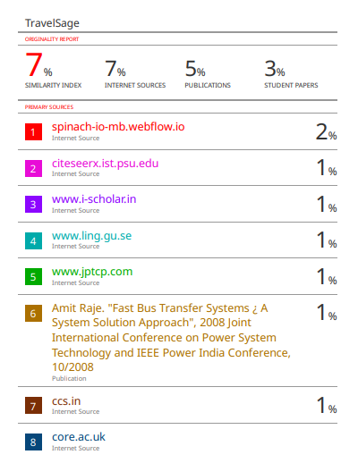

Review-1

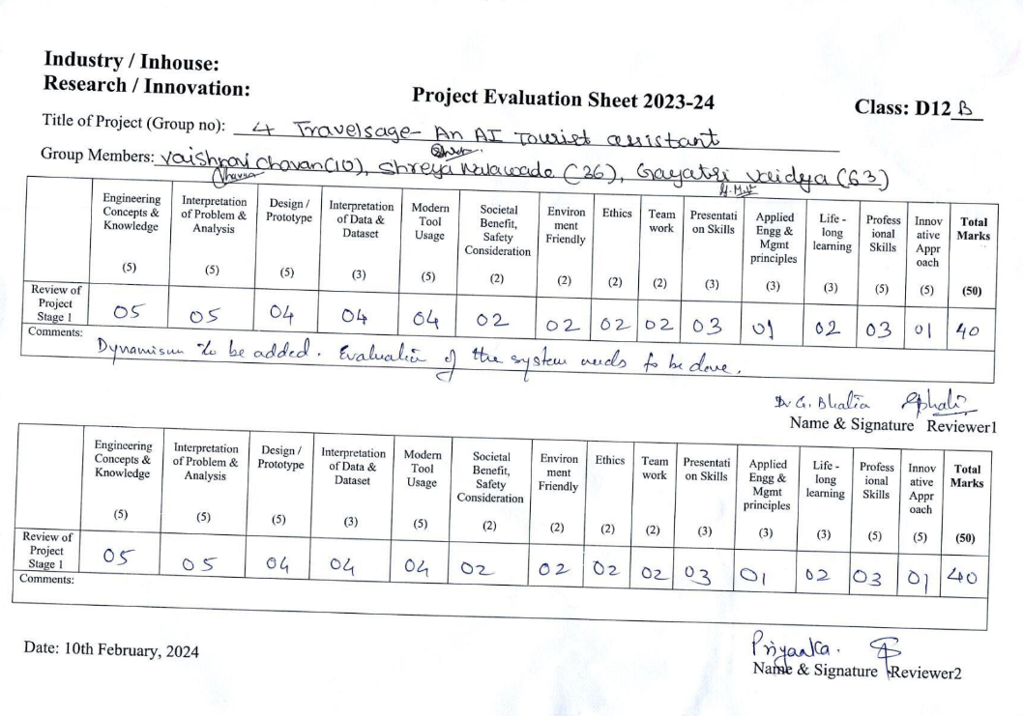

Review sheet-2

